

|  |  |
| --- | --- |
| **Name, Surname** | Doğukan Fikri Arat |
| **Student ID** | 2079648 |
| **Name, Surname** | Saad Yousaf |
| **Student ID** | 2246536 |

**MIDDLE EAST TECHNICAL UNIVERSITY NORTHERN CYPRUS CAMPUS**

**ELECTRICAL AND ELECTRONICS ENGINEERING PROGRAM**

**EEE 446 Computer Architecture II - 2019-2020 Spring**

**8-Bit Multi-Cycle Processor Design and Implementation**

Table of Contents

Table of Figures 3

List of Tables 4

Objectives 5

ISA Specifications and Design 6

R-type 6

I-type 6

J-type 7

CPU Design and Validation 10

Arithmetic Processor 13

16-Bit D-Type Flip Flop 13

4-to-1 Multiplexer 14

8-Bit Shift Register 14

6-to-8 Sign Extension 15

16-Bit Multiplier 15

8-Bit Divider 16

8x8-Bit Register File 16

Memory 17

ISA Validation and Performance 18

Assembler Design 20

CPU Benchmark Definitions and Testing 21

Power Calculation **Error! Bookmark not defined.**

Conclusion 22

Appendix A: Assembler Source Code in C# 23

Appendix B: Source Code of Control Unit 23

# Table of Figures

Figure 1. High level view of the datapath 11

Figure 2. Front panel component 10

Figure 3. Control unit component 10

Figure 4. Arithmetic processor component 13

Figure 5. Simulation of arithmetic processor sub-system 13

Figure 6. 16-Bits register component 13

Figure 7. Simulation of 16-Bit register sub-system 14

Figure 8. 4-to-1 multiplexer component 14

Figure 9. Simulation of 4-to-1 multiplexer sub-system 14

Figure 10. 8-Bits universal shift register component 14

Figure 11. Simulation of 8-bits universal shift register 15

Figure 12. 6-to-8 sign extension component 15

Figure 13. Simulation of 6-to-8 sign extension sus-system 15

Figure 14. 16-Bits multiplier component 15

Figure 15. Simulation of 16-bits multiplier sub-system 16

Figure 16. Division component 16

Figure 17. 8x8 Register file component 16

Figure 18. Simulation of 8x8 register file sub-system 16

Figure 19. 16x1024 Data memory 17

Figure 20. Assembler screenshot **Error! Bookmark not defined.**

# List of Tables

Table 1. R-Type instruction structure 6

Table 2. I-Type instruction structure 6

Table 3. J-Type instruction structure 6

Table 4. Complete Instruction Set Architecture 8

Table 5. Sample assembly code for assembler 20

Table 6. Assembler machine code output 20

# Objectives

In this project, we were responsible for designing and implementing an 8-bit CPU, codename Funtira. We developed and tailored the Multi-8 ISA for Funtira by considering our performance and benchmarking requirements. To convert the assembly code written in Multi-8 assembly language to machine code, we developed the Codalex assembler. In this design report we will give a complete description of our ISA. The detailed high-level and low-level schematics of Funtira will be included in the report to show the CPU design implementation. Test benchmarks compiled using the Codalex assembler will be provided in this report along with their results to demonstrate the functionality and performance of Funtira.

# ISA Specifications and Design

Lorem ipsum

Table 1. R-Type instruction structure

|  |  |  |  |  |  |  |  |  |  |
| --- | --- | --- | --- | --- | --- | --- | --- | --- | --- |
| R-TYPE | | | | | | | | | |
| 4 | | 3 | | 3 | | 3 | | 3 | |
| 15 | 12 | 11 | 9 | 8 | 6 | 5 | 3 | 2 | 0 |
| OPCODE (Op) | | DESTINATION (Rd) | | SOURCE_1 (Rs) | | SOURCE_2 (Rt) | | OAP | |

Table 2. I-Type instruction structure

|  |  |  |  |  |  |  |  |
| --- | --- | --- | --- | --- | --- | --- | --- |
| I-TYPE | | | | | | | |
| 4 | | 3 | | 3 | | 6 | |
| 15 | 12 | 11 | 9 | 8 | 6 | 5 | 0 |
| OPCODE (Op) | | DESTINATION (Rd) | | SOURCE_1 (Rs) | | CONSTANT (C) | |

Table 3. J-Type instruction structure

|  |  |  |  |
| --- | --- | --- | --- |
| J-TYPE | | | |
| 4 | | 12 | |
| 15 | 12 | 11 | 0 |
| OPCODE (Op) | | CONSTANT (C) | |

## R-type

All R-type instructions have a 4-bit opcode, which is 0000 for all R-type instructions. The instruction itself is determined by the 3 OAP bits, which means we have 8 R-type instructions. There are two source registers Rs and Rt, 3-bit address each, and one 3-bit destination register Rd. R-type instructions are arithmetic-logic operations and some of them have immediate versions as well which are defined under I-type instructions.

## I-type

All I-type instructions have a 4-bit OPCODE which is used to identify the instruction as well in the decode stage. The is one destination (Rd) and one source (Rs) register, both having 3-bit addresses. The immediate is a 6-bit constant. This can be used with I-type instructions after sign-extension to 8-bit, since all operations are using 8-bits.

## J-type

We currently have 1 J-type instruction, which is Jump instruction. It has a 4-bit OPCODE and a 12-bit constant which is the destination address for the jump target

Table 4. Complete Instruction Set Architecture

|  |  |  |  |  |  |  |  |
| --- | --- | --- | --- | --- | --- | --- | --- |
| Instruction | Type | CPI | Operands | Description | Operation | Opcode | OAP |
| ADD | R | 4 | Rd, Rs, Rt | Add two registers and a carry (Cin) | Rd <= Rs + Rt + Cin  PC <= PC + 1 | 0 | 0 |
| ADDI | I | 4 | Rd, Rs, C | Add a register and a constant (C) | Rd <= Rs + C  PC <= PC + 1 | 1 | X |
| SUB | R | 4 | Rd, Rs, Rt | Subtract two registers and a carry (Cin) | Rd <= Rs - Rt – Cin  PC <= PC + 1 | 0 | 1 |
| AND | R | 4 | Rd, Rs, Rt | Logical AND two registers | Rd <= Rs ^ Rt  PC <= PC + 1 | 0 | 4 |
| ANDI | I | 4 | Rd, Rs, C | Logical AND two registers and a constant (C) | Rd <= Rs ^ C  PC <= PC + 1 | 2 | X |
| OR | R | 4 | Rd, Rs, Rt | Logical OR two registers | Rd <= Rs v Rt  PC <= PC + 1 | 0 | 3 |
| DMADDR | J | 4 | C | Set most significant 2-bits of Data Memory Address to least significant 2-bits of constant (C) | DM_address[8:9] <= C [1:0]  PC <= PC + 1 | 3 | X |
| XOR | R | 4 | Rd, Rs, Rt | Logical XOR two registers | Rd <= Rs ⊕ Rt  PC <= PC + 1 | 0 | 6 |
| SLT | R | 4 | Rd, Rs, Rt | If Rs<Rt, Rd=1, else Rd=0. | Rs-Rt, Rd <= N (zero flag)  PC <= PC + 1 | 0 | 5 |
| MUL | R | 14 | Rd, Rs, Rt | Multiply two registers | [Rd, Rd+1] <= Rs * Rt  PC <= PC + 1 | 0 | 2 |
| DIV | R | 16 | Rd, Rs, Rt | Divide two registers | Rs / Rt,  [Rd, Rd+1] <= [Q, A]  PC <= PC + 1 | 0 | 7 |
| SLL | I | 3+C | Rd, Rs, C | Logical shift left Rs and save into Rd with constant amount (C) | Rd <= Rs << C  PC <= PC + 1 | 4 | X |
| SRL | I | 3+C | Rd, Rs, C | Logical shift right Rs and save into Rd with constant amount (C) | Rd <= Rs >> C  PC <= PC + 1 | 5 | X |
| SRA | I | 3+C | Rd, Rs, C | Arithmetic shift right Rs and save into Rd with constant amount (C) | Rd <= Rs >> C  PC <= PC + 1 | 6 | X |
| LW | I | 5 | Rd, Rs, C | Load 16-bit word from data memory | [Rd, Rd+1]<=MEM[Rs + C]  PC <= PC + 1 | 7 | X |
| LWU | I | 4 | Rd, Rs, C | Load upper byte from data memory location | [Rd, -] <= MEM[Rs + C]  PC <= PC + 1 | 8 | X |
| LWL | I | 4 | Rd, Rs, C | Load lower byte from data memory location | [-, Rd] <= MEM [Rs + C]  PC <= PC + 1 | 9 | X |
| SW | I | 5 | Rd, Rs, C | Store 16-bit word to data memory | MEM[Rs + C] <= [Rd, Rd+1]  PC <= PC + 1 | 10 | X |
| SWU | I | 4 | Rd, Rs, C | Store 8-bit data to upper byte of data memory location | MEM [Rs + C] <= [Rd, -]  PC <= PC + 1 | 11 | X |
| SWL | I | 4 | Rd, Rs, C | Store 8-bit data to lower byte of data memory location | MEM [Rs + C] <= [-, Rd]  PC <= PC + 1 | 12 | X |
| BREQ | I | 4 | Rd, Rs, D | Branch if Rd equals Rs | if Rs-Rd=0, i.e. Z=1, PC <= PC + D | 13 | X |
| BRNE | I | 4 | Rd, Rs, D | Branch if Rd not equal to Rs | if Rs-Rd! = 0, i.e. Z=0, PC <= PC + D | 14 | X |
| JUMP | J | 4 | D | Jump to address location (C) | PC <= PC+C | 15 | X |
|  |  |  |  | ** D is the jump or branch Destination Address |  |  |  |

# CPU Design and Validation

In this part of the report, top view of the datapath, control unit and front panel is focused on. In Figure 3. High level view of the datapath, datapath can been seen. This unit is consisting of 27 different individual logic components such as multiplexers, registers etc. One base sample of each kind is presented with its symbol and simulation screenshots.

Users can access the front panel component which allows to run the machine or to select between manual or auto-clock. This component is seen in Figure 1. Front panel component. The control unit is following the front panel since it has the priority to work on datapath. The control unit is presented in Figure 2. Control unit component. All the Verilog code is also appended to appendix parts.

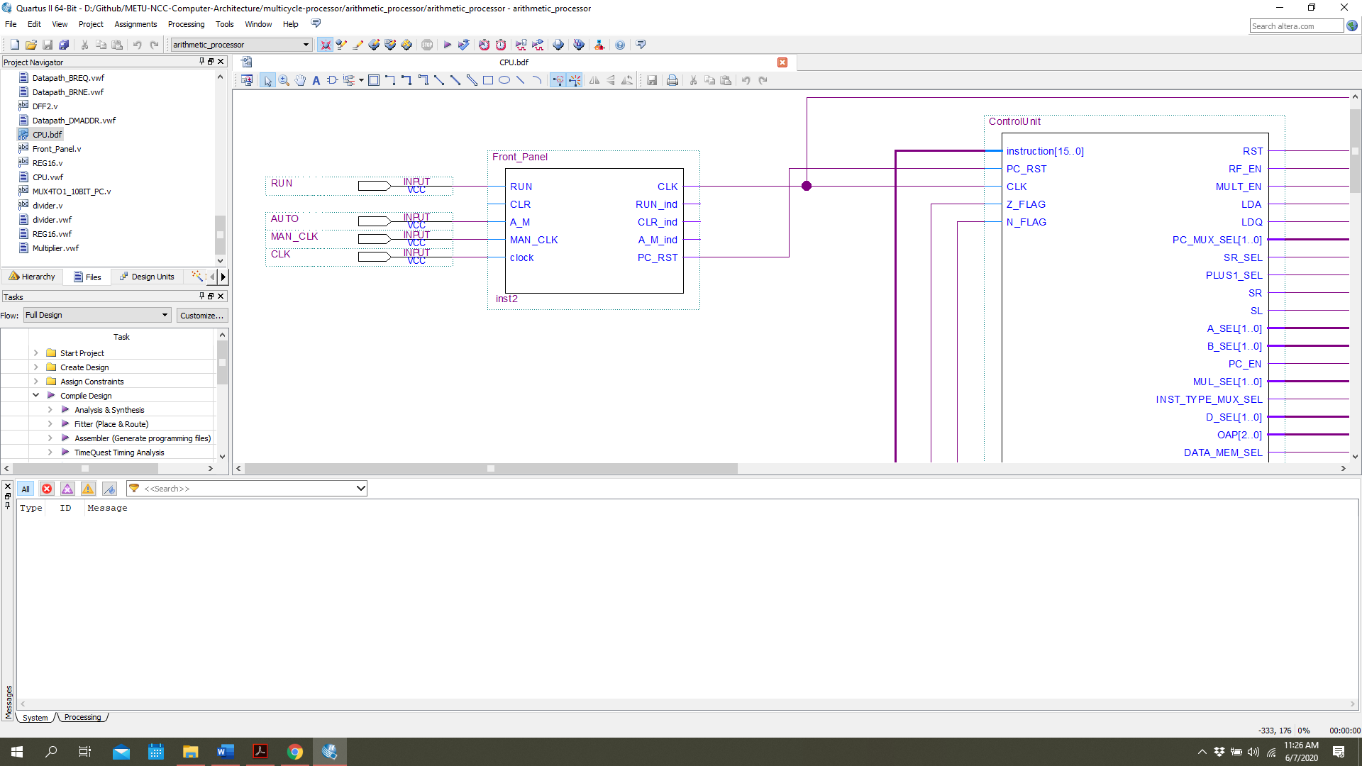

Figure 1. Front panel component

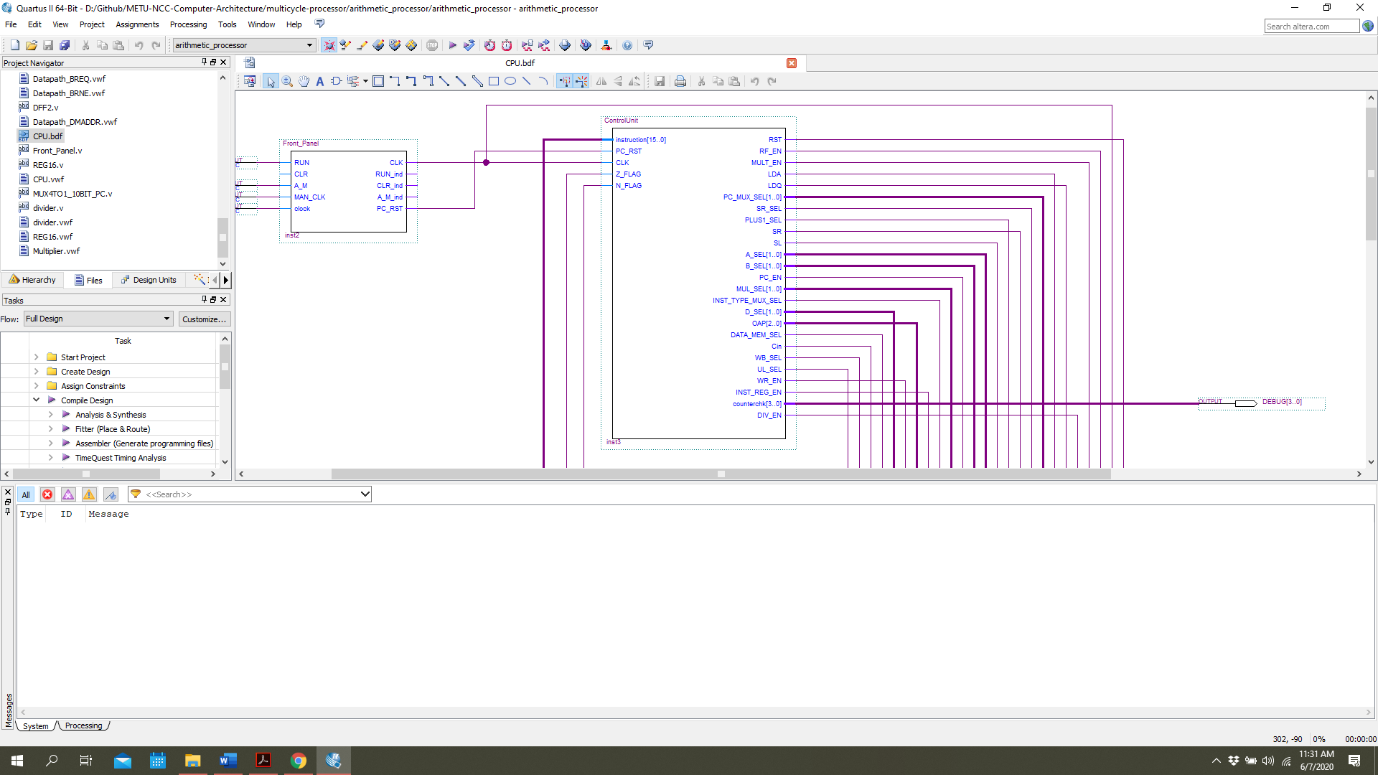

Figure 2. Control unit component

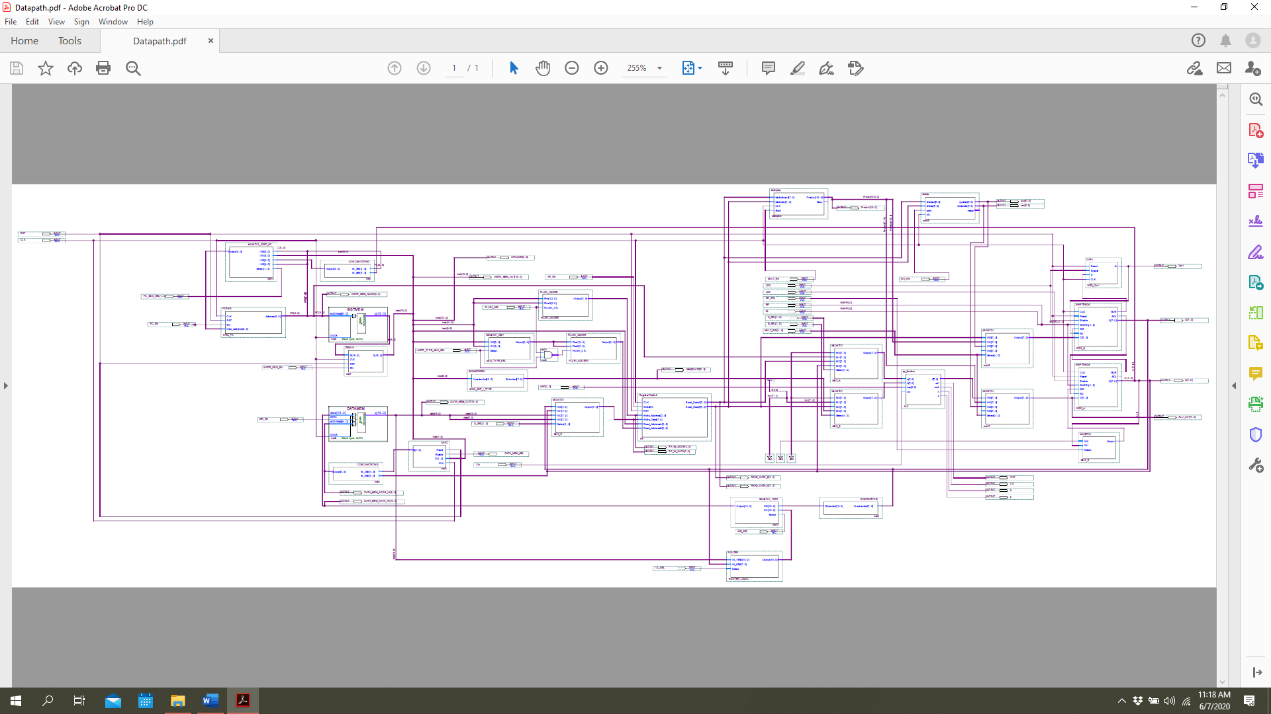

Figure 3. High level view of the datapath

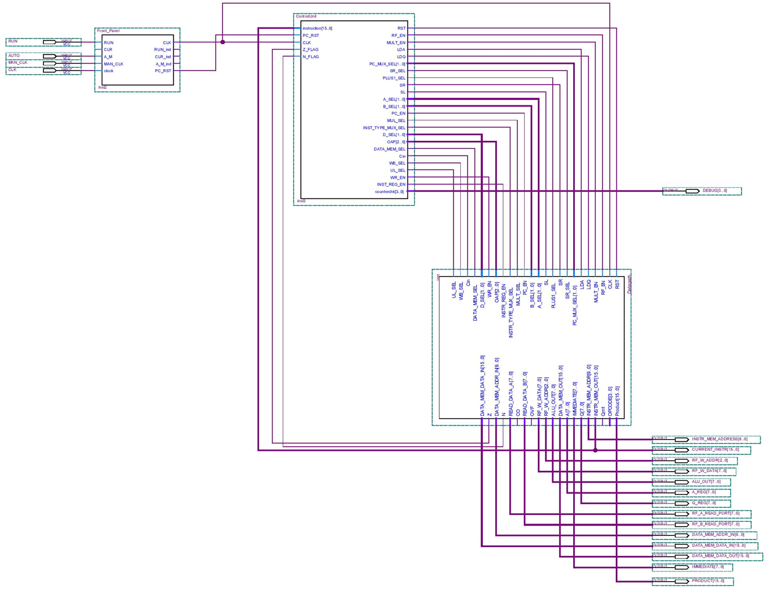

Figure 4. High level view of CPU

## Arithmetic Processor

The core of the datapath is arithmetic processor since all the arithmetic operation, some of which are addition, subtraction etc., is done in this part of the data path. Control of the arithmetic processor is handled by control unit and OAP selection of R-type instructions. The component is placed in datapath with the symbol which can be seen in Figure 5. Arithmetic processor component. Validation of the component can be observed in Figure 6. Simulation of arithmetic processor sub-system.

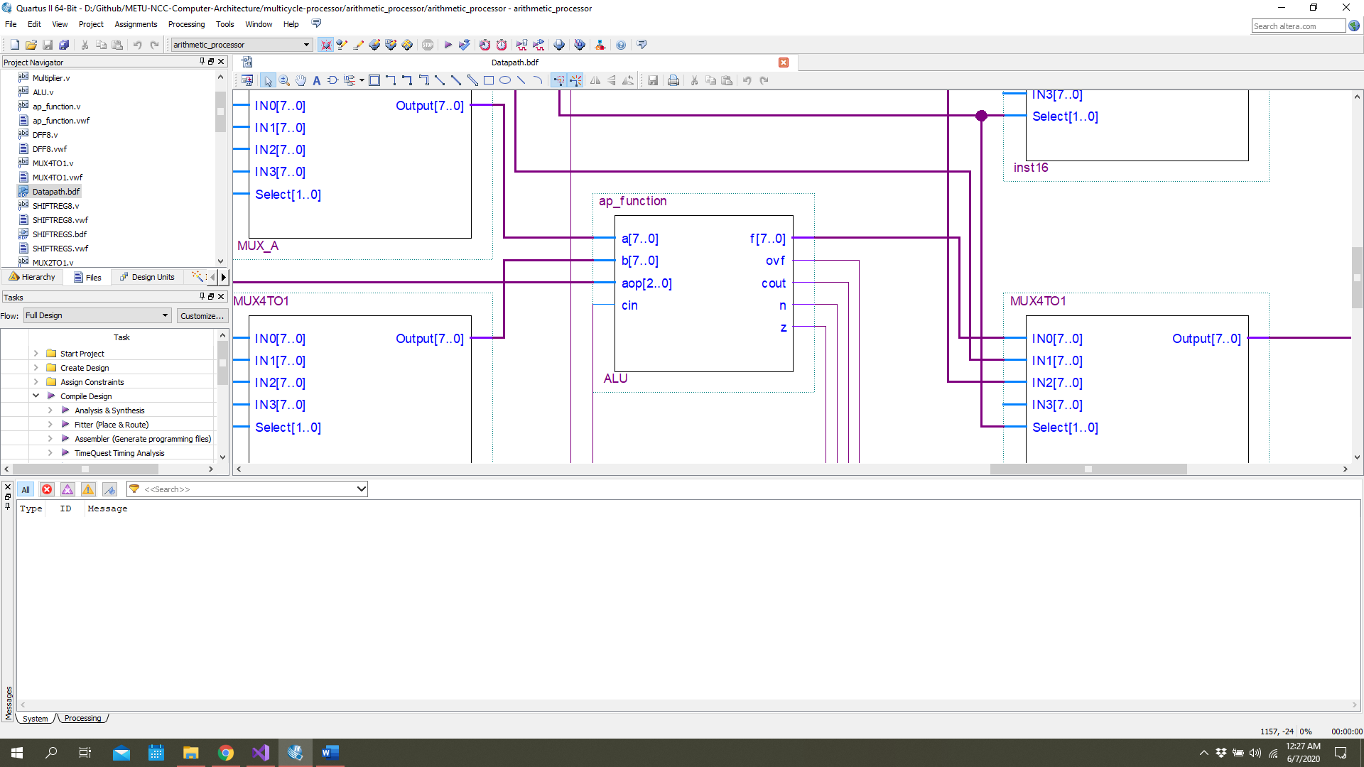

Figure 5. Arithmetic processor component

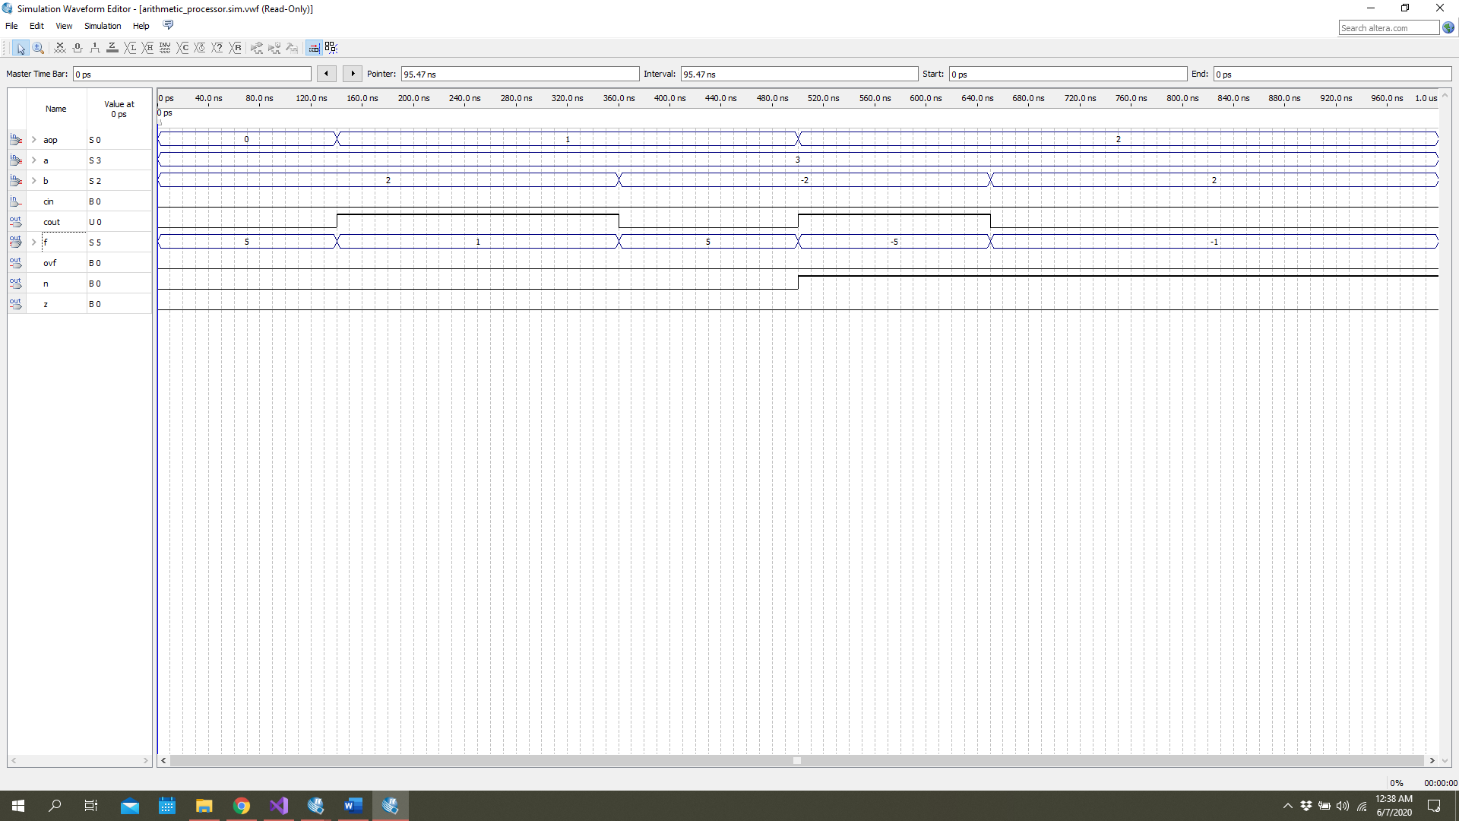

Figure 6. Simulation of arithmetic processor sub-system

## 16-Bit D-Type Flip Flop

Since a processor with high execution performance cannot be though without data storage elements. Our datapath also has some data storage elements. In the datapath, there are 4 main data storage elements. One of them is basic one which is used to store the instruction coming from instruction memory since our datapath is multi-cycle datapath. The block symbol is seen in datapath with input-output ports and presented in Figure 7. 16-Bits register component. Validation of the component is done, and the result is in Figure 8. Simulation of 16-Bit register sub-system.

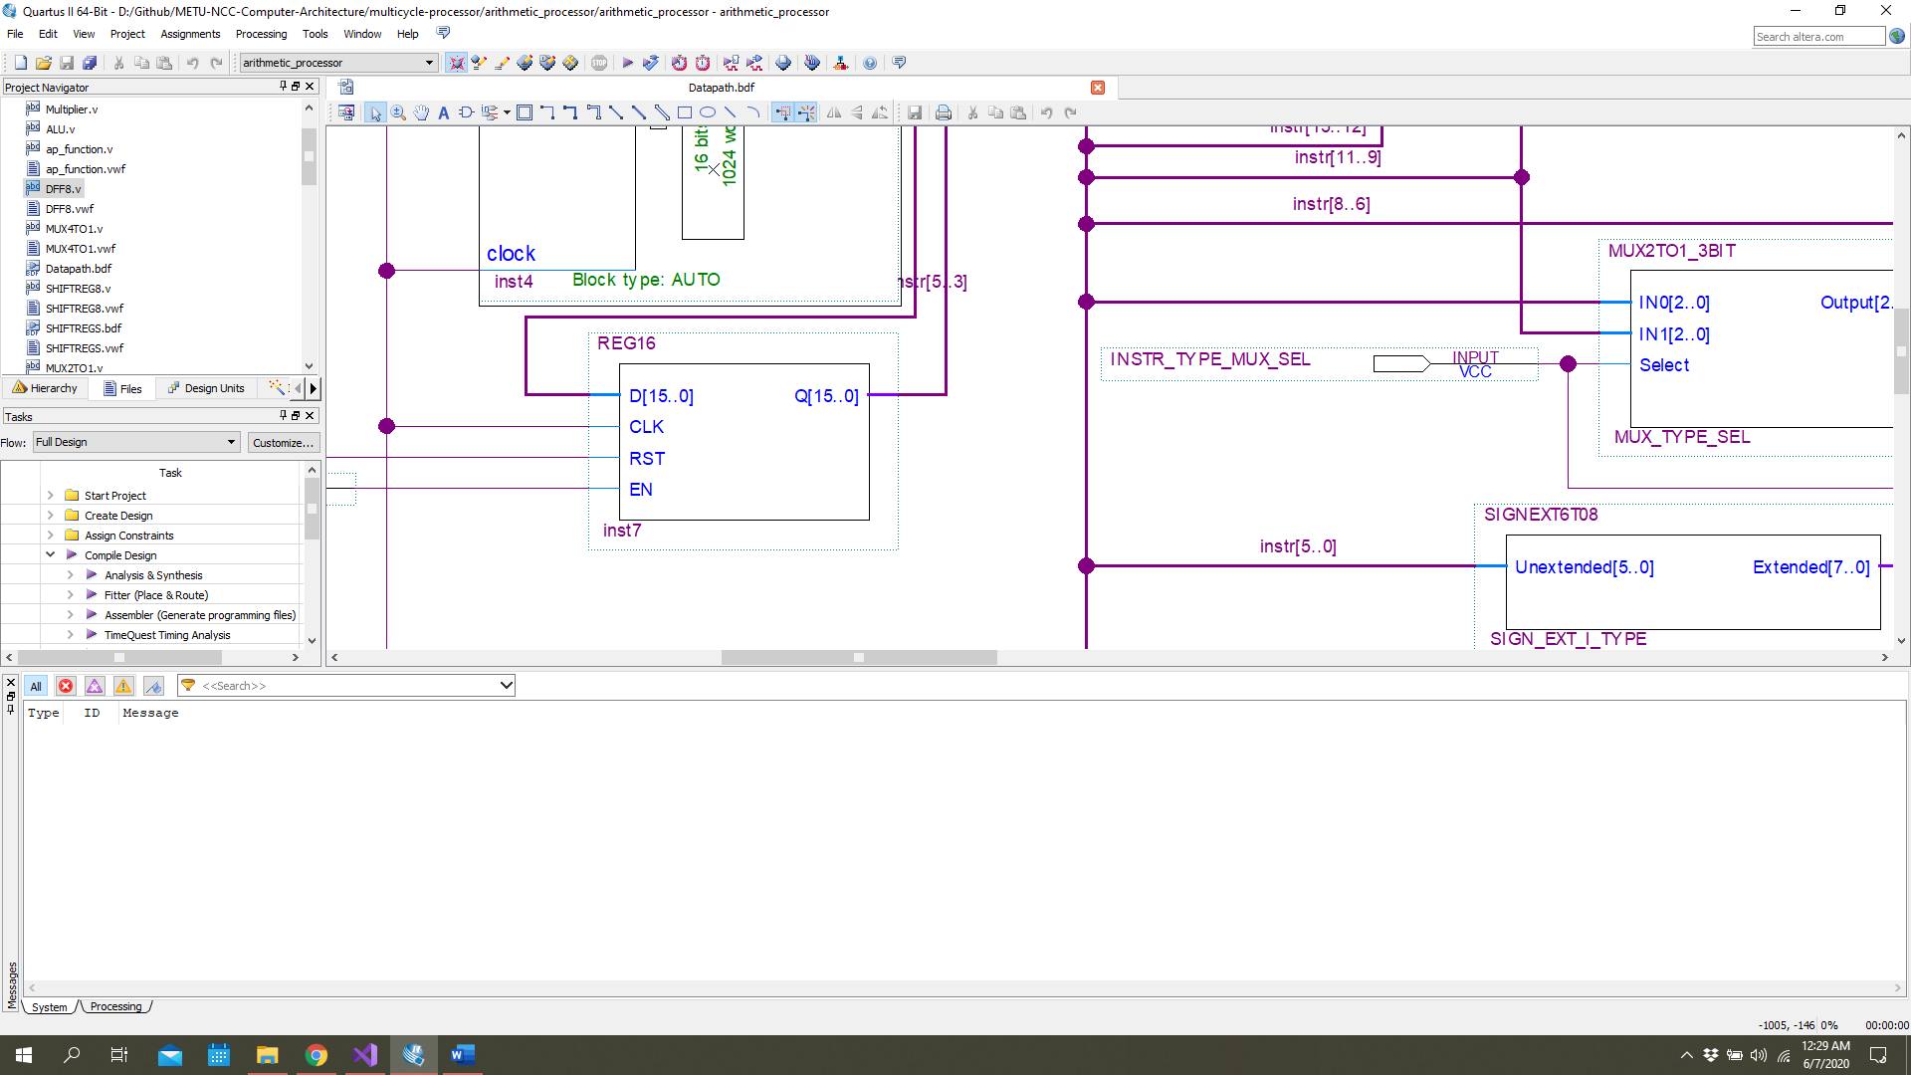

Figure 7. 16-Bits register component

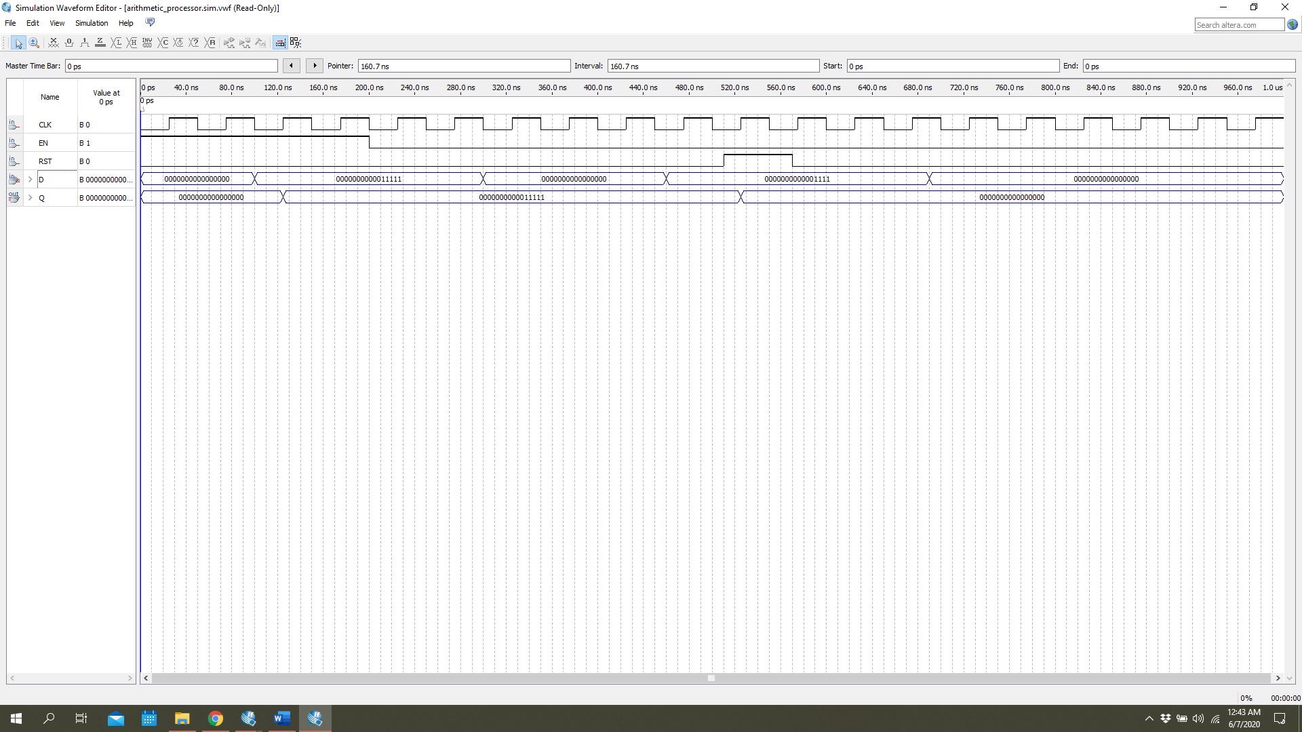

Figure 8. Simulation of 16-Bit register sub-system

## 4-to-1 Multiplexer

In order to route the data for processing, the multiplexers are heavily used. In Figure 9. 4-to-1 multiplexer component, one of them is given. This block is used while routing the write data of the register file in the datapath. The simulation shows its functionality in Figure 10. Simulation of 4-to-1 multiplexer sub-system.

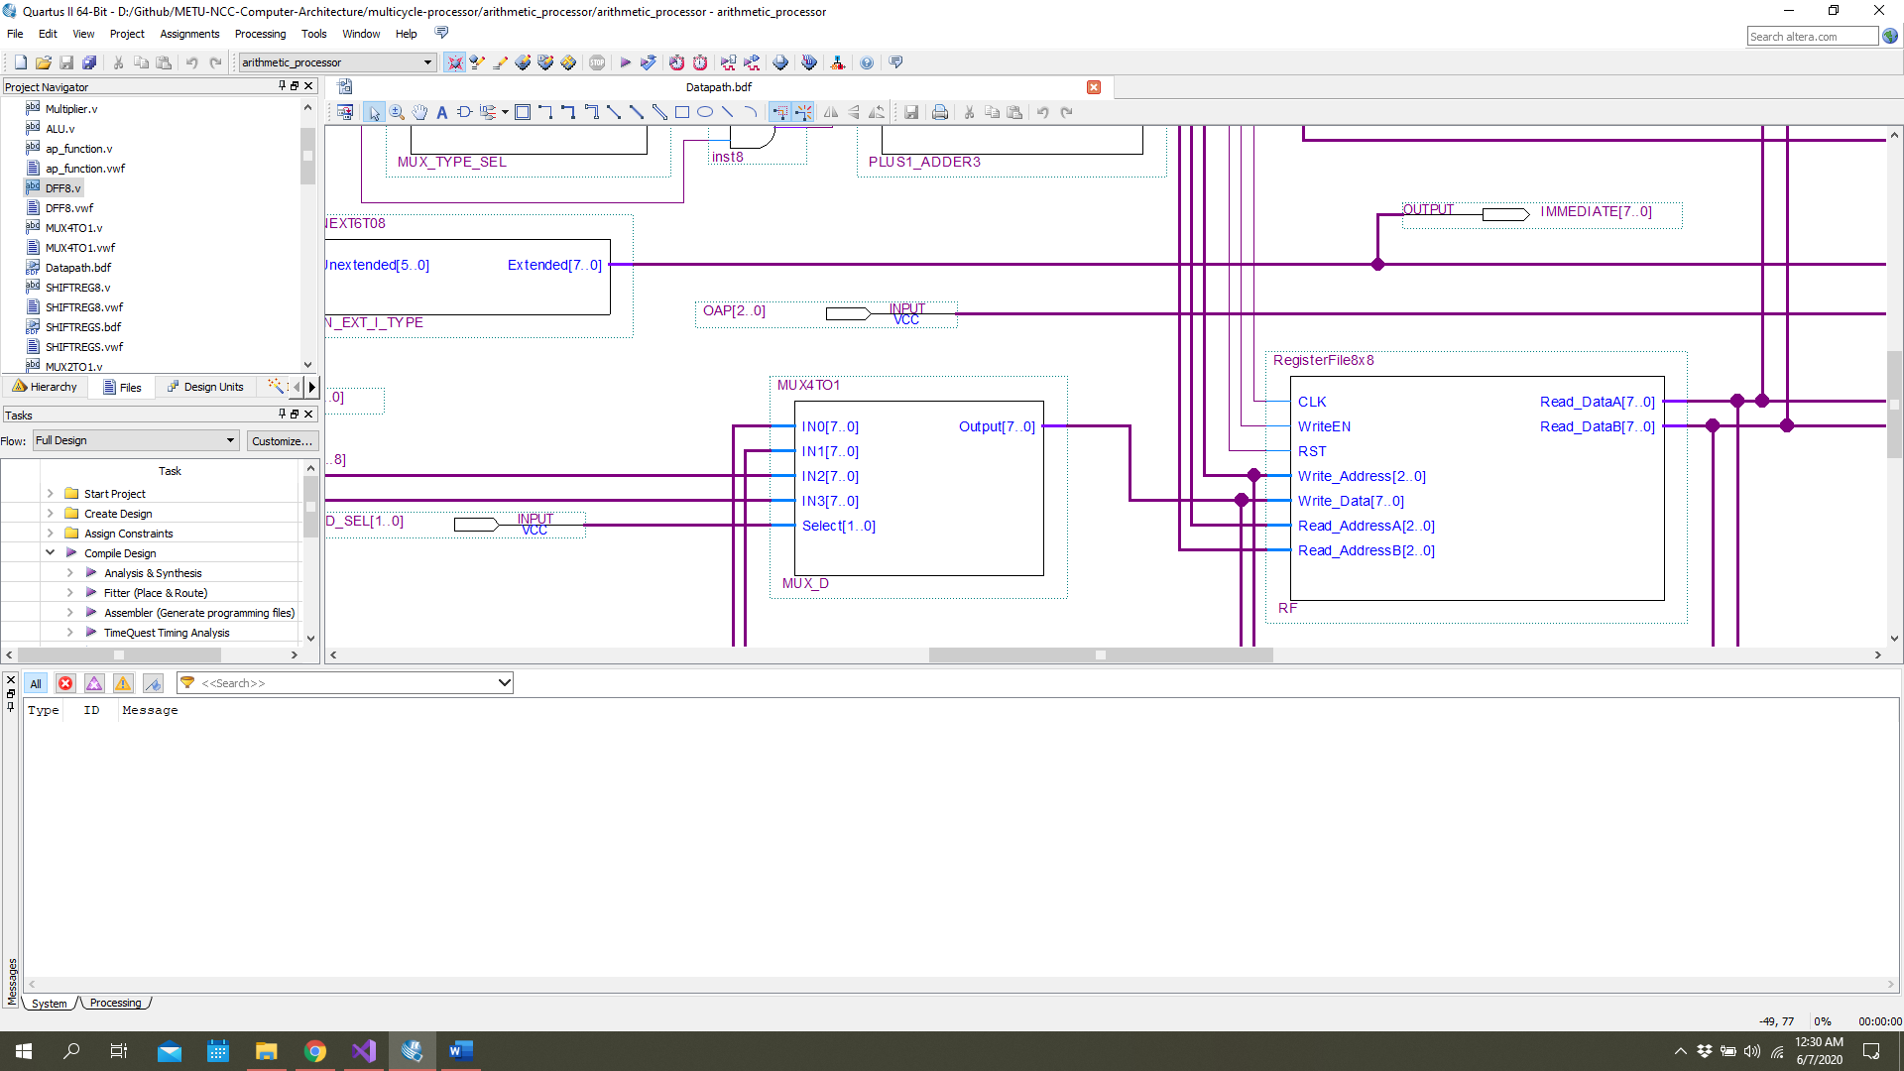

Figure 9. 4-to-1 multiplexer component

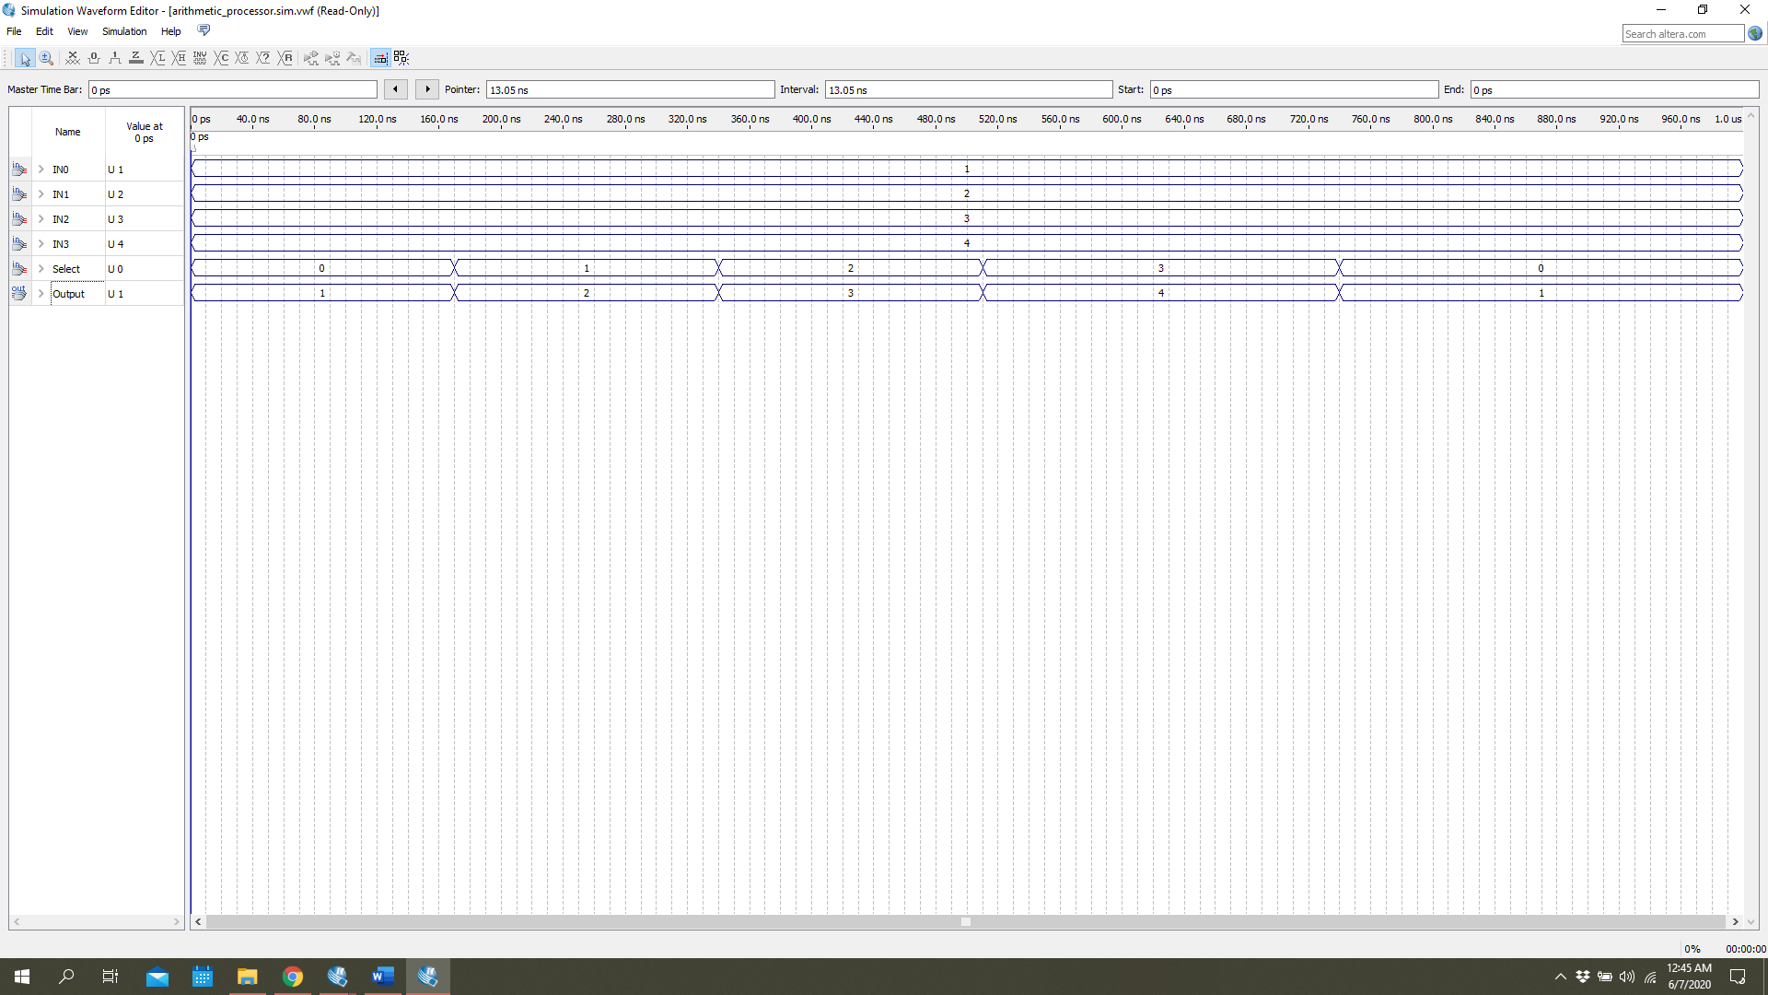

Figure 10. Simulation of 4-to-1 multiplexer sub-system

## 8-Bit Shift Register

The other data storage element is 8-bits universal shift registers. In the datapath, we have two of them while storing the data to save into register file or data memory. Also, the shifting operation is handled in the part of the datapath. The component can be seen in Figure 11. 8-Bits universal shift register component. In Figure 12. Simulation of 8-bits universal shift register, the functionality is presented.

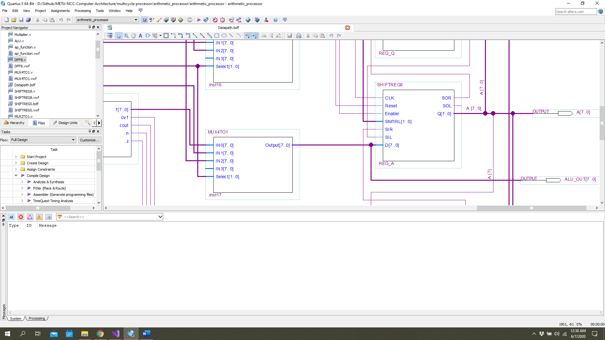

Figure 11. 8-Bits universal shift register component

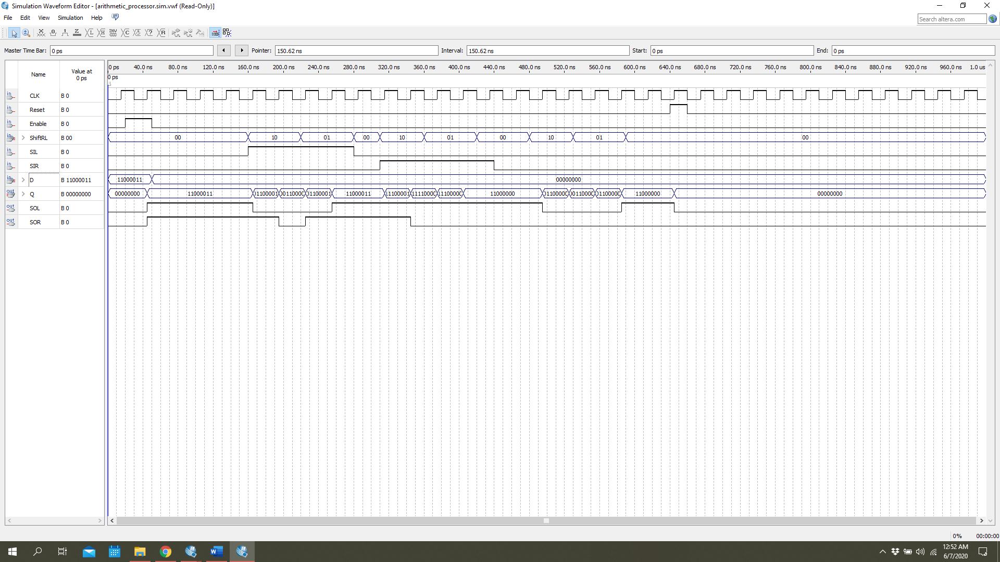

Figure 12. Simulation of 8-bits universal shift register

## 6-to-8 Sign Extension

To execute the signed numbers, we need to store to data unsigned version. Since we have minimum 8-bit size registers while getting max 6-bit constant by I-type instruction, the constant data should be extended to store it without any problem. In this case, sign extension block is used. The component can be seen in Figure 13. 6-to-8 sign extension component. The validation is done and presented in Figure 13. 6-to-8 sign extension component.

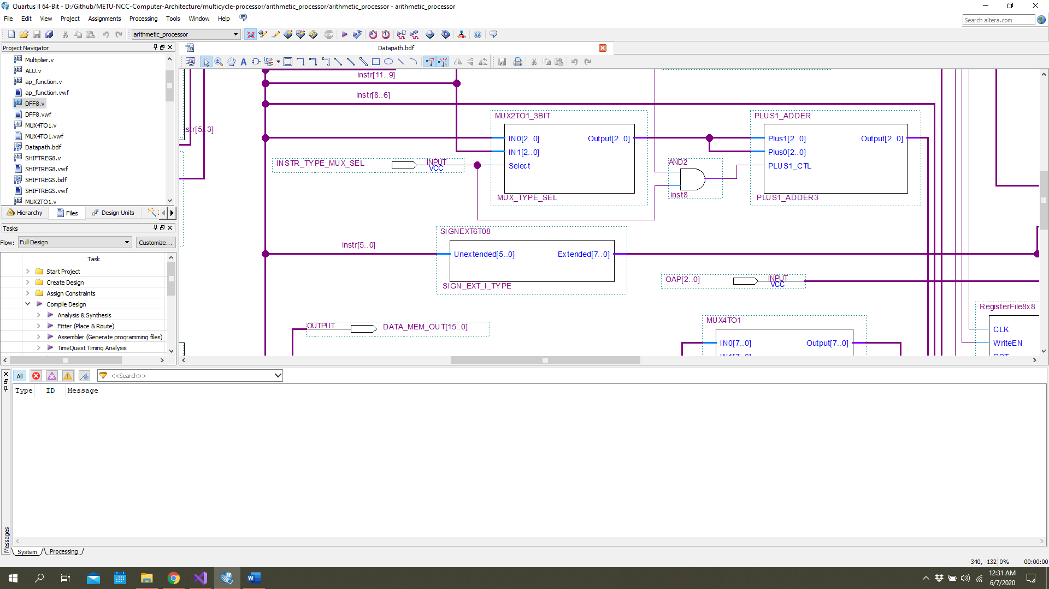

Figure 13. 6-to-8 sign extension component

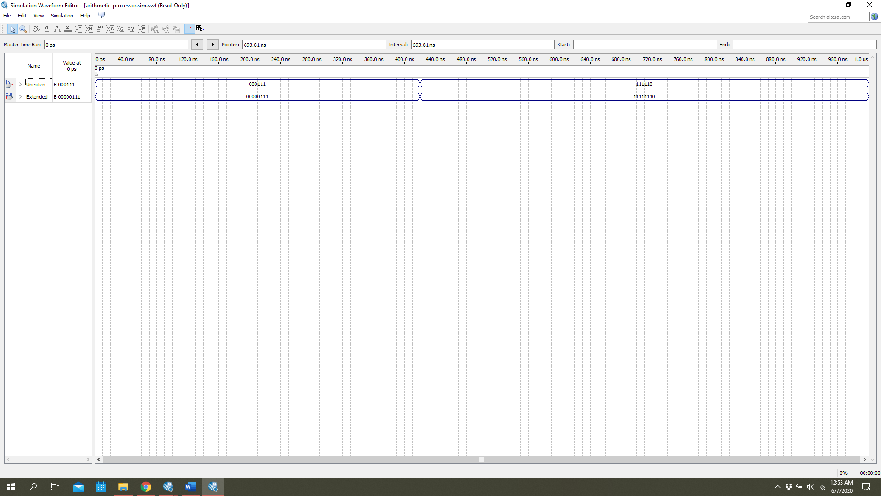

Figure 14. Simulation of 6-to-8 sign extension sus-system

## 16-Bit Multiplier

Since we implement Booths algorithm for multiplication, the multiplication process is different than any other kind of arithmetic operation like addition and it take more than 1 clock cycle to execute. Therefore, for the multiplication, the induvial block is need. This block can be seen in Figure 15. 16-Bits multiplier component. The control sequence and the validation result can be checked in Figure 16. Simulation of 16-bits multiplier sub-system

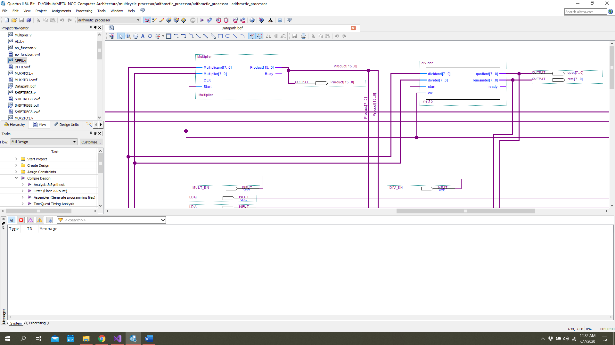

Figure 15. 16-Bits multiplier component

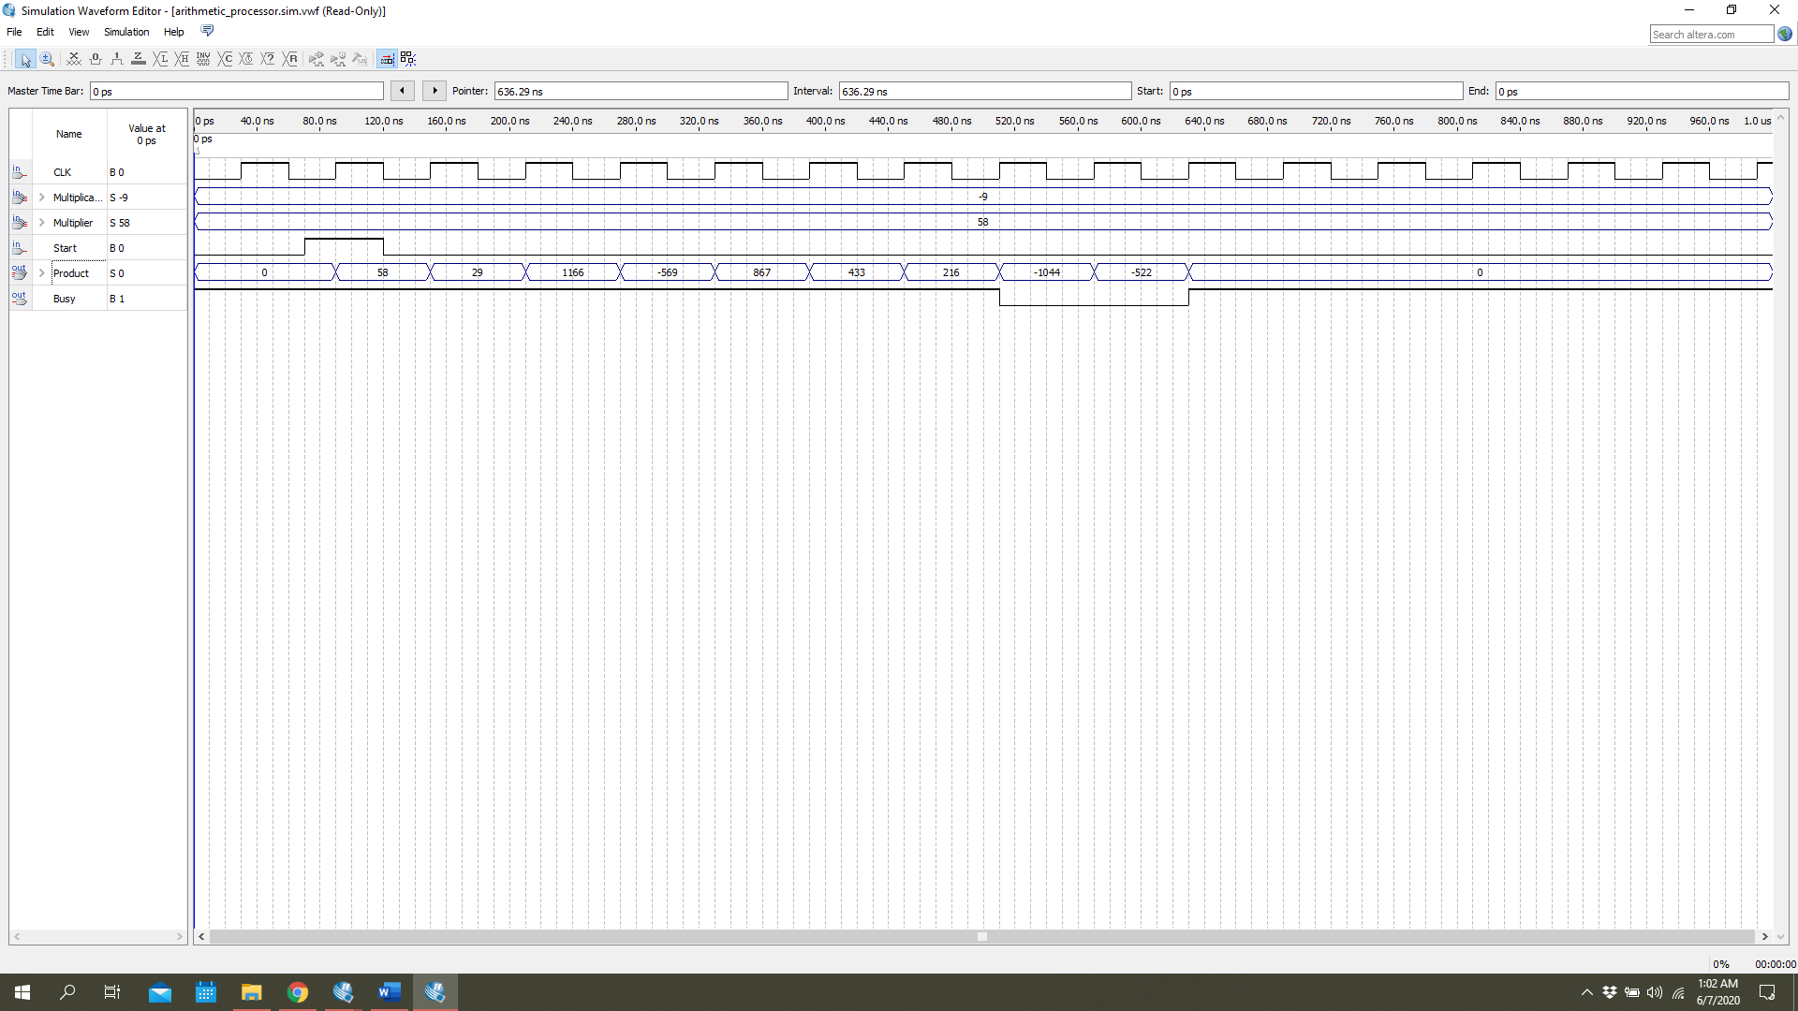

Figure 16. Simulation of 16-bits multiplier sub-system

## 8-Bit Divider

As like multiplication, the division operation require different block as well. Therefore, for the division, in the datapath, there is separate block. This block is presented in Figure 17. Division component.

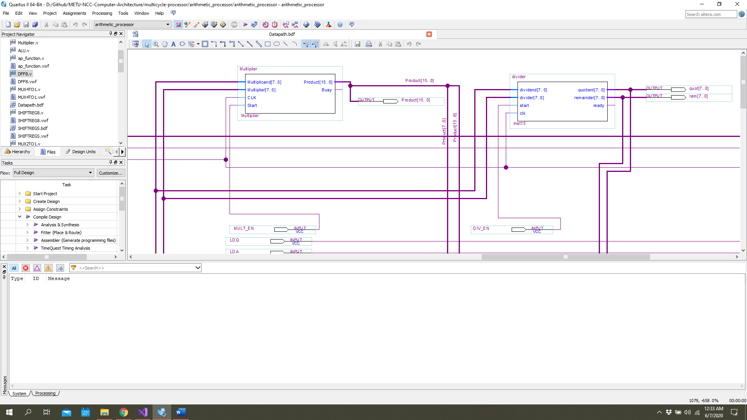

Figure 17. Division component

## 8x8-Bit Register File

One of the main component of the datapaths is obviously register files. Therefore, our datapath includes 8 block register files, which block is storing 8 bit data. With this block, while we can read two data at the same time, there is only one write port. The input-output ports of the register file can be seen in Figure 18. 8x8 Register file component. The operations of the register file is simulated, and the result is presented in Figure 19. Simulation of 8x8 register file sub-system.

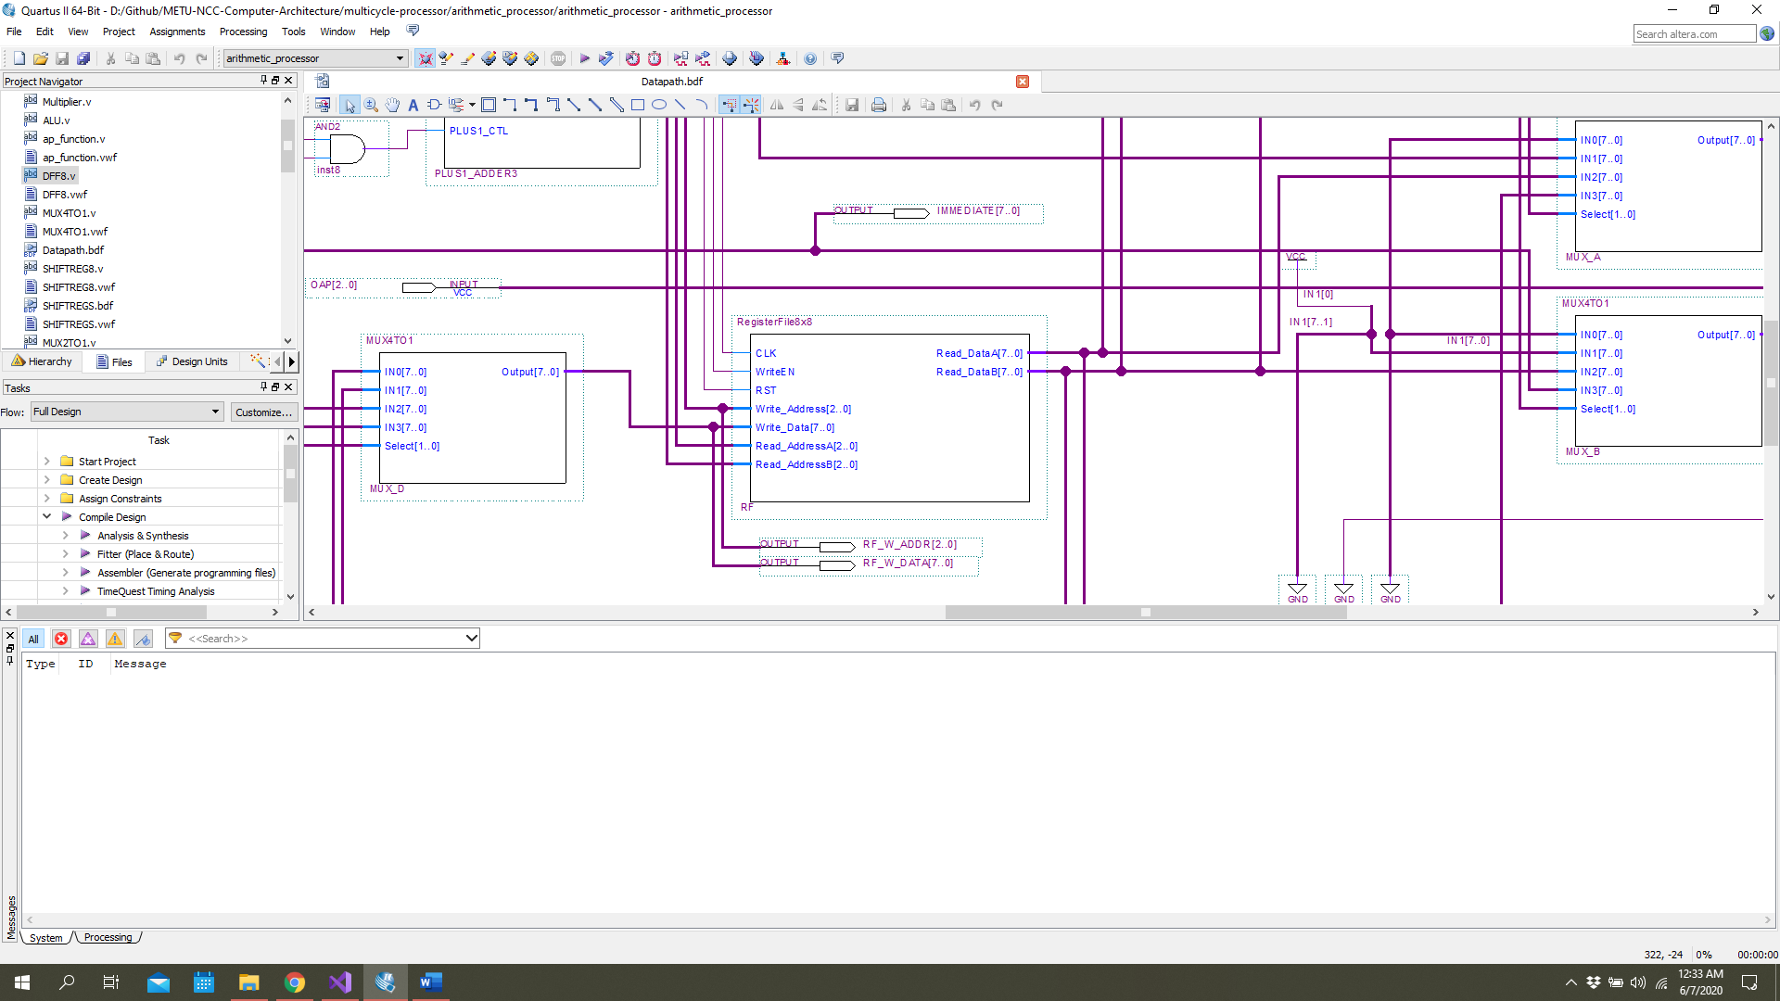

Figure 18. 8x8 Register file component

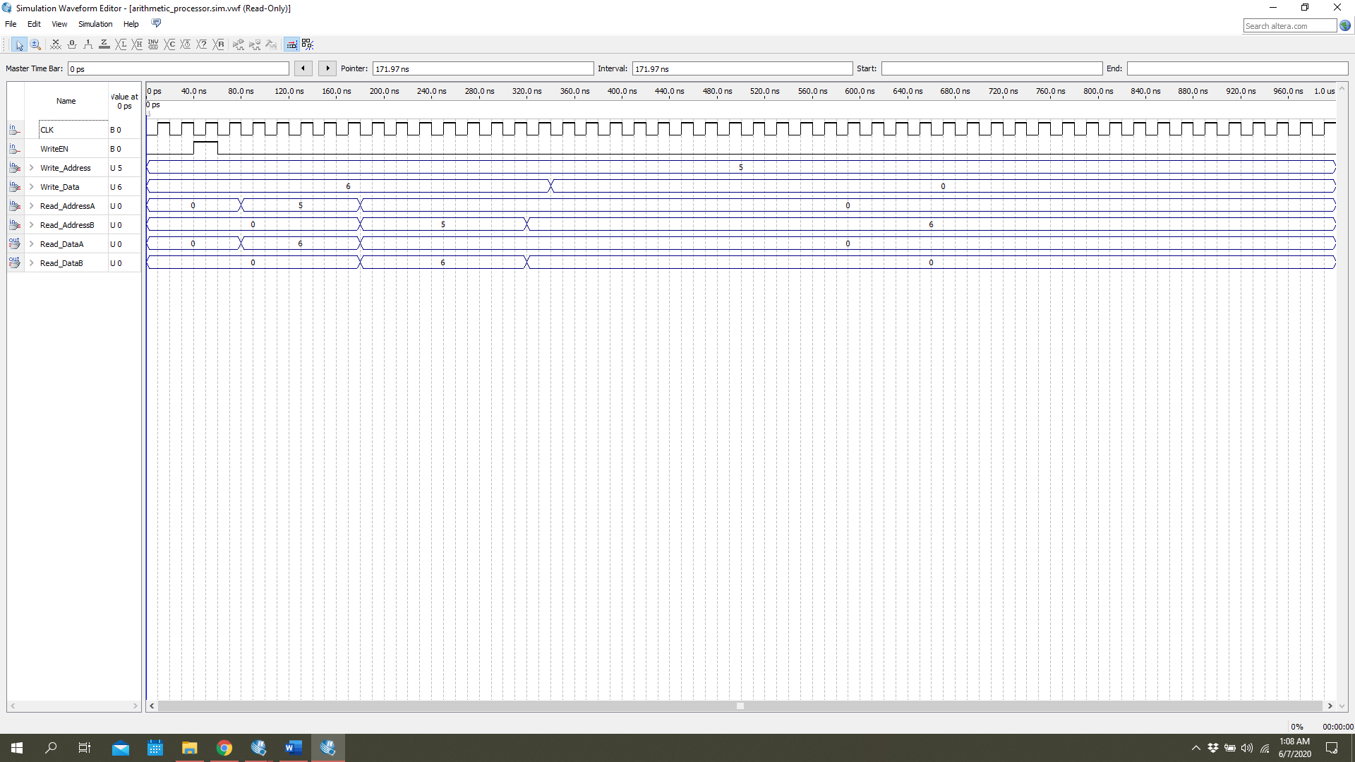

Figure 19. Simulation of 8x8 register file sub-system

## Memory

As a big portion of the CPU, in the datapath, we have 2 1022 words 16-bits data memory block, one of which is for instruction memory, and the other one is for data memory. This pre-defined block is adjusted for our requirements and added to the datapath. The block symbol is seen in Figure 20. 16x1024 Data memory

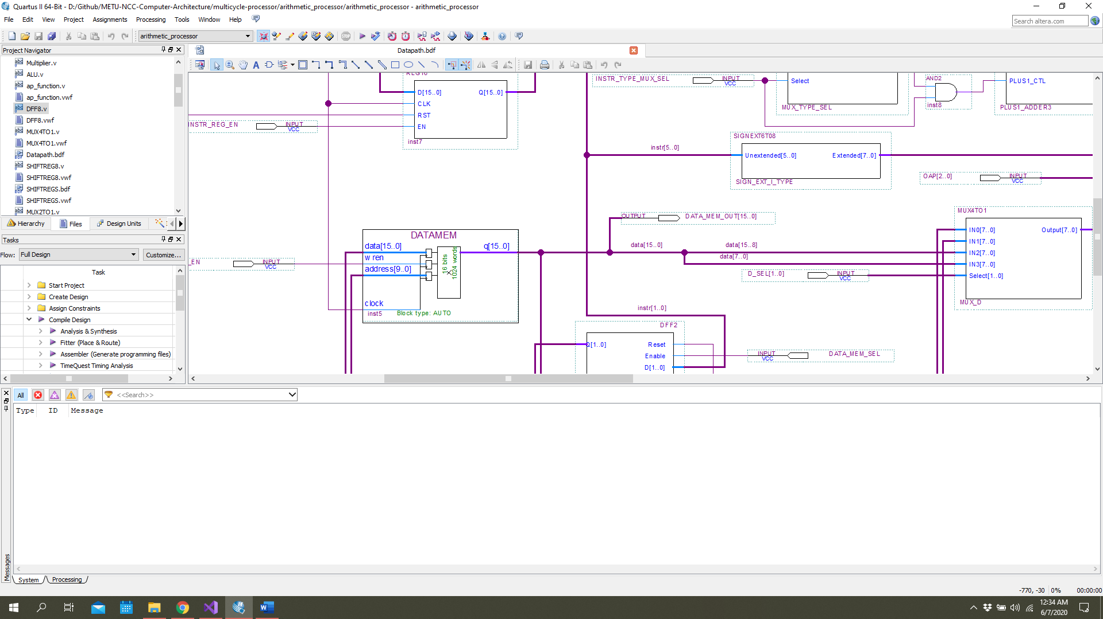

Figure 20. 16x1024 Data memory

# ISA Validation and Performance

asdads

# Assembler Design

In the assembler design of the project, one of the strong high-level language, which is C# is chosen. C# is one of Microsoft product. This OOP language is very fast and stable. The source code of the assembler is given in the appendix. To debug the written code, this assembler helps the user to see some inside information for the assembled code piece.

For the sample code in Table 5. Sample assembly code for assembler, the assembler shows the information in Figure 21. Assembler software screenshot with sample code. The output of the assembler is shown in Table 6. Assembler machine code output.

Table 5. Sample assembly code for assembler

|  |
| --- |
| LW $R0, $R0, 0  DIV $R2, $R0, $R1  SW $R2, $R4, 1  INF:  JUMP INF |

Table 6. Assembler machine code output

|  |
| --- |
| 0111000000000000  0000010000001111  1010010100000001  1111000000000011 |

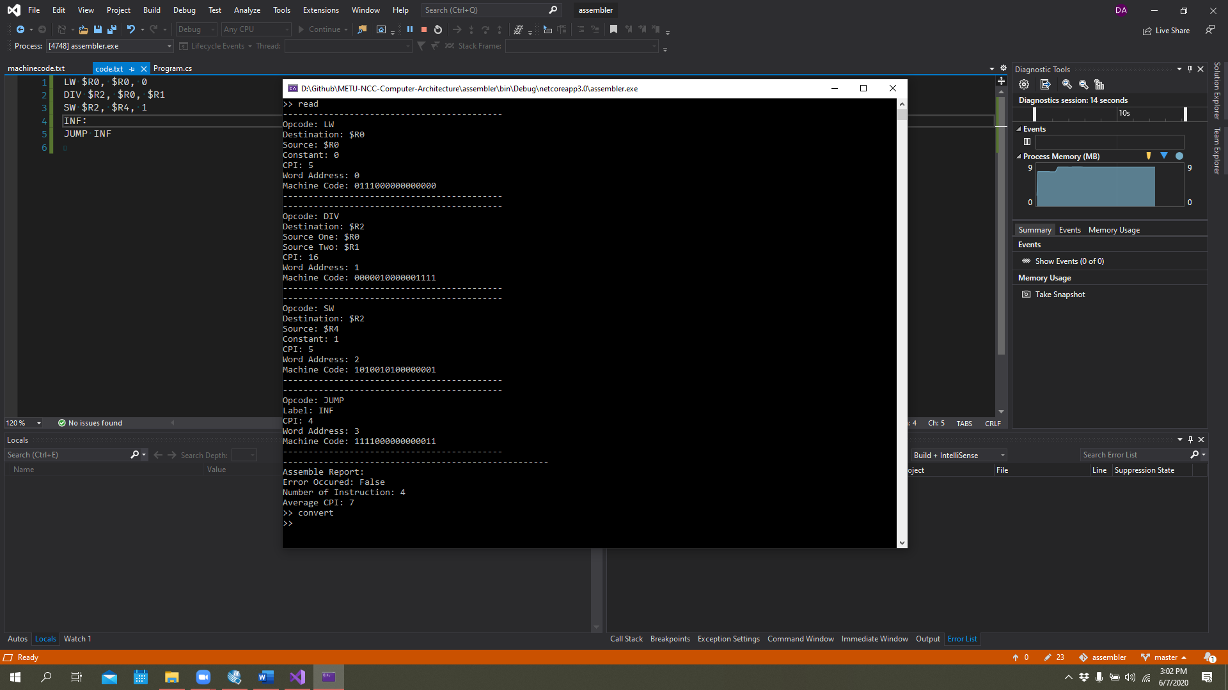

Figure 21. Assembler software screenshot with sample code

# CPU Benchmark Definitions and Testing

Lorem ipsum

# Conclusion

As a result of this project, a good example of a multi-cycle processor is presented. Each component in datapath is simulated and shown. After testing the datapath, control unit is design and tested on top of the datapath. For the user interface front panel is added. Moreover, for the ISA, which is presented in the report, a .Net platform base assembler is designed, tested and used while testing the benchmarks. The benchmarks are pointing very common daily life programs, some of which are 1-D array computation, text parsing and arithmetic operation like multiplications division. As engineer candidates, after we did all the calculations, and simulations on computers, we also tested our work on FPGA development board. The result is well. Since the software we are using considers the environmental is very hard while working on timing simulations. On the room temperature conditions, the design is reached to 50 MHz clock frequency. It means that in the design processes, the system is designed in efficient way.

# Appendix A: Assembler Source Code in C#

using System;

using System.IO;

using System.Collections.Generic;

namespace assembler

{

public class Content

{

public static List<Instruction> Instructions = new List<Instruction>();

public static List<Label> Labels = new List<Label>();

public static List<string> Instruction_Content = new List<string>();

public static bool Assemble_Error;

public static int Average_CPI;

public static int Num_Of_Instructions;

}

public class Instruction

{

public string Opcode { get; set; }

public string Destination { get; set; }

public string Source_One { get; set; }

public string Source_Two { get; set; }

public int Position { get; set; }

public int CPI { get; set; }

public string Binary_Opcode { get; set; }

public string Binary_Destination { get; set; }

public string Binary_Source_One { get; set; }

public string Binary_Source_Two { get; set; }

public string Binary_Function { get; set; }

public string Binary_Constant { get; set; }

public string Binary_MachineCode { get; set; }

public string Type { get; set; }

public void Print()

{

Console.WriteLine("-------------------------------------------");

Console.WriteLine($"Opcode: {Opcode}");

if(this.Type == "R")

{

Console.WriteLine($"Destination: {Destination}");

Console.WriteLine($"Source One: {Source_One}");

Console.WriteLine($"Source Two: {Source_Two}");

}

if(this.Type == "I")

{

Console.WriteLine($"Destination: {Destination}");

Console.WriteLine($"Source: {Source_One}");

Console.WriteLine($"Constant: {Source_Two}");

}

if(this.Type == "J")

{

if(this.Opcode == "JUMP")

{

Console.WriteLine($"Label: {Source_Two}");

} else

{

Console.WriteLine($"Constant: {Source_Two}");

}

}

Console.WriteLine($"CPI: {CPI}");

Console.WriteLine($"Word Address: {Position}");

Console.WriteLine($"Machine Code: {Binary_MachineCode}");

Console.WriteLine("-------------------------------------------");

}

public void Encode()

{

try

{

var Types = new Dictionary<string, string> {

{ "ADD", "R"},

{ "ADDI", "I"},

{ "SUB", "R" },

{ "AND", "R" },

{ "ANDI", "I" },

{ "OR", "R" },

{ "DMADDR", "J" },

{ "XOR", "R" },

{ "SLT", "R" },

{ "MUL", "R" },

{ "DIV", "R" },

{ "SLL", "I" },

{ "SRL", "I" },

{ "SRA", "I" },

{ "LW", "I" },

{ "LWU", "I" },

{ "LWL", "I" },

{ "SW", "I" },

{ "SWU", "I" },

{ "SWL", "I" },

{ "BREQ", "I" },

{ "BRNE", "I" },

{ "JUMP", "J" }

};

var CPI = new Dictionary<string, int> {

{ "ADD", 4},

{ "ADDI", 4},

{ "SUB", 4},

{ "AND", 4},

{ "ANDI", 4},

{ "OR", 4},

{ "DMADDR", 4},

{ "XOR", 4},

{ "SLT", 4},

{ "MUL", 14},

{ "DIV", 16},

{ "SLL", 3},

{ "SRL", 3},

{ "SRA", 3},

{ "LW", 5},

{ "LWU", 4},

{ "LWL", 4},

{ "SW", 5},

{ "SWU", 4},

{ "SWL", 4},

{ "BREQ", 4},

{ "BRNE", 4},

{ "JUMP", 4}

};

var BinaryOpcodes = new Dictionary<string, string> {

{ "ADD", "0000"},

{ "ADDI", "0001"},

{ "SUB", "0000" },

{ "AND", "0000" },

{ "ANDI", "0010" },

{ "OR", "0000" },

{ "DMADDR", "0011" },

{ "XOR", "0000" },

{ "SLT", "0000"},

{ "MUL", "0000" },

{ "DIV", "0000" },

{ "SLL", "0100" },

{ "SRL", "0101" },

{ "SRA", "0110" },

{ "LW", "0111" },

{ "LWU", "1000" },

{ "LWL", "1001" },

{ "SW", "1010" },

{ "SWU", "1011" },

{ "SWL", "1100" },

{ "BREQ", "1101" },

{ "BRNE", "1110" },

{ "JUMP", "1111" }

};

var BinaryFunctions = new Dictionary<string, string> {

{ "ADD", "000"},

{ "SUB", "001" },

{ "AND", "100" },

{ "OR", "011" },

{ "XOR", "110" },

{ "SLT", "101"},

{ "MUL", "010" },

{ "DIV", "111" },

};

var BinaryRegisters = new Dictionary<string, string>

{

{ "$R0", "000"},

{ "$R1", "001"},

{ "$R2", "010"},

{ "$R3", "011"},

{ "$R4", "100"},

{ "$R5", "101"},

{ "$R6", "110"},

{ "$R7", "111"}

};

this.Type = Types[Opcode];

this.Binary_Opcode = BinaryOpcodes[Opcode];

this.CPI = CPI[Opcode];

if (this.Type == "R")

{

this.Binary_Function = BinaryFunctions[Opcode];

this.Binary_Destination = BinaryRegisters[this.Destination];

this.Binary_Source_One = BinaryRegisters[this.Source_One];

this.Binary_Source_Two = BinaryRegisters[this.Source_Two];

this.Binary_MachineCode = this.Binary_Opcode + this.Binary_Destination + this.Binary_Source_One + this.Binary_Source_Two + this.Binary_Function;

}

if (this.Type == "I")

{

if (this.Opcode == "BREQ" || this.Opcode == "BRNE")

{

this.Binary_Destination = BinaryRegisters[this.Destination];

this.Binary_Source_One = BinaryRegisters[this.Source_One];

foreach (Label label in Content.Labels)

{

if (label.Name == this.Source_Two)

{

int Offset = label.Instruction_Position - this.Position - 2;

this.Binary_Constant = Convert.ToString(Offset, 2).PadLeft(6, '0');

}

}

}

else

{

this.Binary_Destination = BinaryRegisters[this.Destination];

this.Binary_Source_One = BinaryRegisters[this.Source_One];

this.Binary_Constant = Convert.ToString(Convert.ToInt32(this.Source_Two), 2).PadLeft(6, '0');

}

if (this.Binary_Constant.Length > 6)

{

this.Binary_Constant = this.Binary_Constant.Substring(this.Binary_Constant.Length - 6);

}

this.Binary_MachineCode = this.Binary_Opcode + this.Binary_Destination + this.Binary_Source_One + this.Binary_Constant;

}

if (this.Type == "J")

{

if (this.Opcode == "JUMP")

{

foreach (Label label in Content.Labels)

{

if (label.Name == this.Source_Two)

{

this.Binary_Constant = Convert.ToString(label.Instruction_Position, 2).PadLeft(12, '0');

}

}

this.Binary_MachineCode = this.Binary_Opcode + this.Binary_Constant;

}

else

{

this.Binary_Constant = Convert.ToString(Convert.ToInt32(this.Source_Two), 2).PadLeft(12, '0');

if (this.Binary_Constant.Length > 12)

{

this.Binary_Constant = this.Binary_Constant.Substring(this.Binary_Constant.Length - 12);

}

this.Binary_MachineCode = this.Binary_Opcode + this.Binary_Constant;

}

}

}

catch (Exception e)

{

Console.WriteLine("Error occured. {0} Exception caught.", e);

Content.Assemble_Error = true;

}

}

public string Get_MachineCode()

{

return this.Binary_MachineCode;

}

}

public class Label

{

public string Name { get; set; }

public int Instruction_Position { get; set; }

public void Print()

{

Console.WriteLine($"{Name} @ {Instruction_Position}");

}

}

public class Datapath

{

Dictionary<string, string>BinaryRegisters = new Dictionary<string, string>

{

{ "$R0", "000"},

{ "$R1", "001"},

{ "$R2", "010"},

{ "$R3", "011"},

{ "$R4", "100"},

{ "$R5", "101"},

{ "$R6", "110"},

{ "$R7", "111"}

};

public int Program_Counter { get; set; }

public void Next()

{

}

}

class Program

{

static void Main(string[] args)

{

string command = "None";

while (command != "exit")

{

Console.Write(">> ");

command = Console.ReadLine();

if(command == "read")

{

string[] lines = File.ReadAllLines(Path.Combine(Environment.CurrentDirectory, "..\\..\\..\\code.txt"));

int instruction_position = 0;

foreach (string line in lines)

{

string label = "";

string opcode = "";

string destination = "";

string source_one = "";

string source_two = "";

string temp = "";

for (int counter = 0; counter<line.Length; counter++)

{

if(line[counter].Equals(':'))

{

label = temp;

temp = "";

}

if(Char.IsWhiteSpace(line[counter]) & !(opcode.Length>0))

{

opcode = temp;

temp = "";

}

if(line[counter].Equals(',') & (opcode.Length > 0) & !(destination.Length > 0))

{

destination = temp;

temp = "";

}

if(line[counter].Equals(',') & (destination.Length > 0) & !(source_one.Length > 0))

{

source_one = temp;

temp = "";

}

temp = $"{temp}{line[counter]}";

if(counter == line.Length - 1 || line[counter+1].Equals('#'))

{

source_two = temp;

temp = "";

break;

}

}

label = label.Trim(' ', ',', '#', ':').ToUpper();

opcode = opcode.Trim(' ', ',', '#', ':').ToUpper();

destination = destination.Trim(' ', ',', '#', ':').ToUpper();

source_one = source_one.Trim(' ', ',', '#', ':').ToUpper();

source_two = source_two.Trim(' ', ',', '#', ':').ToUpper();

if (label.Length > 0)

Content.Labels.Add(new Label {

Name = label,

Instruction_Position = instruction_position

});

if( opcode.Length > 0 )

{

Content.Instructions.Add(new Instruction {

Opcode = opcode,

Destination = destination,

Source_One = source_one,

Source_Two = source_two,

Position = instruction_position

});

instruction_position++;

}

// End of the line

}

foreach (Instruction instruction in Content.Instructions)

{

instruction.Encode();

instruction.Print();

Content.Average_CPI += instruction.CPI;

Content.Instruction_Content.Add(instruction.Get_MachineCode());

}

Content.Num_Of_Instructions = Content.Instructions.Count;

Content.Average_CPI /= Content.Num_Of_Instructions;

Console.WriteLine("----------------------------------------------------");

Console.WriteLine("Assemble Report:");

Console.WriteLine("Error Occured: {0}", Content.Assemble_Error);

Console.WriteLine("Number of Instruction: {0}", Content.Num_Of_Instructions);

Console.WriteLine("Average CPI: {0}", Content.Average_CPI);

}

if(command == "convert")

{

String[] MachineCodeLines = Content.Instruction_Content.ToArray();

System.IO.File.WriteAllLines(Path.Combine(Environment.CurrentDirectory, "..\\..\\..\\machinecode.txt"), MachineCodeLines);

}

}

}

}

}

# Appendix B: Source Code of Control Unit

module ControlUnit(instruction,

PC_RST,

RST,

CLK,

RF_EN,

MULT_EN,

LDA, LDQ,

PC_MUX_SEL,

SR_SEL,

PLUS1_SEL,

SR,

SL,

A_SEL,

B_SEL,

PC_EN,

MUL_SEL,

INST_TYPE_MUX_SEL,

D_SEL,

OAP,

DATA_MEM_SEL,

Cin,

WB_SEL,

UL_SEL,

WR_EN,

INST_REG_EN,

Z_FLAG,

N_FLAG,

counterchk,

DIV_EN);

output reg RST, RF_EN, MULT_EN, LDA, LDQ, SR_SEL, PLUS1_SEL, SR, SL, PC_EN, DIV_EN, INST_TYPE_MUX_SEL, DATA_MEM_SEL, Cin, WB_SEL, UL_SEL, WR_EN, INST_REG_EN;

output reg [1:0] PC_MUX_SEL, A_SEL, B_SEL, D_SEL, MUL_SEL;

output reg [2:0] OAP;

output reg [3:0] counterchk;

input CLK, PC_RST, Z_FLAG, N_FLAG;

input [15:0] instruction;

integer Count, ShiftCount, MultCount ,DivCount;

integer available, fetch, shift_available, mult_available, div_available, temp_Z;

initial

begin

RST = 1'b1;

Count = 0;

ShiftCount = 0;

MultCount = 0;

DivCount = 0;

MUL_SEL = 2'b00;

MULT_EN = 0; DIV_EN = 0;

DIV_EN = 0;

available = 0;

PC_MUX_SEL = 0;

INST_REG_EN = 0;

PC_EN = 0;

fetch = 1;

available = 0;

shift_available = 0;

mult_available = 0;

div_available = 0;

end

always @(posedge CLK)

begin

RST = 1'b0;

if (available == 0) begin

Count = 0;

ShiftCount = 0;

MultCount = 0;

DivCount = 0;

end

if (fetch == 0) begin

INST_REG_EN = 0;

PC_EN = 0;

end

if (ShiftCount !== 0) begin

ShiftCount = ShiftCount - 1;

Count = Count - 1;

end

if (MultCount !== 0) begin

MultCount = MultCount - 1;

Count = Count - 1;

end

if (DivCount !== 0) begin

DivCount = DivCount - 1;

Count = Count - 1;

end

if (fetch) begin

INST_REG_EN = 1;

PC_EN = 1;

fetch = 0;

available = 1;

end

if (available) begin

Count = Count + 1;

end

counterchk = Count;

case (instruction[15:12])

4'b0000: // R-type

begin

if(instruction[2:0] == 3'b111) begin // DIV

case(Count)

4'b0010:

begin

A_SEL = 2'b00;

B_SEL = 2'b00;

D_SEL = 2'b01;

INST_TYPE_MUX_SEL = 0;

LDA = 0;

LDQ = 0;

MULT_EN = 0;

DIV_EN = 0;

MUL_SEL = 2'b00;

PC_MUX_SEL = 0;

PLUS1_SEL = 0;

RF_EN = 0;

OAP = 3'b0;

fetch = 0;

end

4'b0011:

begin

A_SEL = 2'b00;

B_SEL = 2'b00;

D_SEL = 2'b01;

INST_TYPE_MUX_SEL = 0;

LDA = 0;

LDQ = 0;

MULT_EN = 0;

DIV_EN = 1;

MUL_SEL = 2'b10;

PC_MUX_SEL = 0;

PLUS1_SEL = 0;

RF_EN = 0;

MUL_SEL = 2'b10;

OAP = 3'b0;

fetch = 0;

end

4'b0100:

begin

if(DivCount == 0 && div_available == 0) begin

DivCount = 6;

div_available = 1;

end

if( div_available == 1 ) begin

if(DivCount == 0) begin

div_available= 0;

end

else begin

end

end

DIV_EN = 1;

D_SEL = 2'b01;

end

4'b0101:

begin

A_SEL = 2'b00;

B_SEL = 2'b00;

D_SEL = 2'b01;

INST_TYPE_MUX_SEL = 0;

LDA = 1;

LDQ = 1;

MULT_EN = 0; DIV_EN = 0;

DIV_EN = 0;

MUL_SEL = 2'b10;

PC_MUX_SEL = 0;

PLUS1_SEL = 0;

RF_EN = 0;

MUL_SEL = 2'b10;

OAP = 3'b0;

fetch = 0;

end

4'b0110:

begin

A_SEL = 2'b00;

B_SEL = 2'b00;

D_SEL = 2'b01;

INST_TYPE_MUX_SEL = 0;

LDA = 0;

LDQ = 0;

MULT_EN = 0; DIV_EN = 0;

DIV_EN = 0;

MUL_SEL = 2'b10;

PC_MUX_SEL = 0;

PLUS1_SEL = 0;

RF_EN = 1;

MUL_SEL = 2'b10;

OAP = 3'b0;

fetch = 0;

end

4'b0111:

begin

A_SEL = 2'b00;

B_SEL = 2'b00;

D_SEL = 2'b00;

INST_TYPE_MUX_SEL = 0;

LDA = 0;

LDQ = 0;

MULT_EN = 0; DIV_EN = 0;

DIV_EN = 0;

MUL_SEL = 2'b10;

PC_MUX_SEL = 0;

PLUS1_SEL = 1;

RF_EN = 1;

MUL_SEL = 2'b10;

OAP = 3'b0;

available = 0;

fetch = 1;

end

endcase

end

else if(instruction[2:0] == 3'b010) begin // MUL

case(Count)

4'b0010:

begin

A_SEL = 2'b00;

B_SEL = 2'b00;

D_SEL = 2'b01;

INST_TYPE_MUX_SEL = 0;

LDA = 0;

LDQ = 0;

MULT_EN = 0; DIV_EN = 0;

MUL_SEL = 2'b00;

PC_MUX_SEL = 0;

PLUS1_SEL = 0;

RF_EN = 0;

OAP = 3'b0;

fetch = 0;

end

4'b0011:

begin

A_SEL = 2'b00;

B_SEL = 2'b00;

D_SEL = 2'b01;

INST_TYPE_MUX_SEL = 0;

LDA = 0;

LDQ = 0;

MULT_EN = 1;

MUL_SEL = 2'b01;

PC_MUX_SEL = 0;

PLUS1_SEL = 0;

RF_EN = 0;

MUL_SEL = 2'b01;

OAP = 3'b0;

fetch = 0;

end

4'b0100:

begin

if(MultCount == 0 && mult_available == 0) begin

MultCount = 7;

mult_available = 1;

end

if( mult_available == 1 ) begin

if(MultCount == 0) begin

mult_available= 0;

end

else begin

end

end

MULT_EN = 0; DIV_EN = 0;

D_SEL = 2'b01;

end

4'b0101:

begin

A_SEL = 2'b00;

B_SEL = 2'b00;

D_SEL = 2'b01;

INST_TYPE_MUX_SEL = 0;

LDA = 1;

LDQ = 1;

MULT_EN = 0; DIV_EN = 0;

MUL_SEL = 2'b01;

PC_MUX_SEL = 0;

PLUS1_SEL = 0;

RF_EN = 0;

MUL_SEL = 2'b01;

OAP = 3'b0;

fetch = 0;

end

4'b0110:

begin

A_SEL = 2'b00;

B_SEL = 2'b00;

D_SEL = 2'b01;

INST_TYPE_MUX_SEL = 0;

LDA = 0;

LDQ = 0;

MULT_EN = 0; DIV_EN = 0;

MUL_SEL = 2'b01;

PC_MUX_SEL = 0;

PLUS1_SEL = 0;

RF_EN = 1;

MUL_SEL = 2'b01;

OAP = 3'b0;

fetch = 0;

end

4'b0111:

begin

A_SEL = 2'b00;

B_SEL = 2'b00;

D_SEL = 2'b00;

INST_TYPE_MUX_SEL = 0;

LDA = 0;

LDQ = 0;

MULT_EN = 0; DIV_EN = 0;

MUL_SEL = 2'b01;

PC_MUX_SEL = 0;

PLUS1_SEL = 1;

RF_EN = 1;

MUL_SEL = 2'b01;

OAP = 3'b0;

available = 0;

fetch = 1;

end

endcase

end

else if(instruction[2:0] == 3'b101) begin // SLT

case(Count)

4'b0010:

begin

A_SEL = 2'b10;

B_SEL = 2'b10;

D_SEL = 2'b01;

INST_TYPE_MUX_SEL = 0;

LDA = 0;

LDQ = 0;

MULT_EN = 0; DIV_EN = 0;

MUL_SEL = 2'b00;

PC_MUX_SEL = 0;

PLUS1_SEL = 0;

RF_EN = 0;

OAP = 3'b001;

fetch = 0;

end

4'b0011:

begin

if(N_FLAG == 1 ) begin

A_SEL = 2'b00;

B_SEL = 2'b01;

D_SEL = 2'b01;

INST_TYPE_MUX_SEL = 0;

LDA = 1;

LDQ = 0;

MULT_EN = 0; DIV_EN = 0;

MUL_SEL = 2'b00;

PC_MUX_SEL = 0;

PLUS1_SEL = 0;

RF_EN = 0;

OAP = instruction[2:0];

fetch = 0;

end

if(N_FLAG == 0 ) begin

A_SEL = 2'b00;

B_SEL = 2'b00;

D_SEL = 2'b01;

INST_TYPE_MUX_SEL = 0;

LDA = 1;

LDQ = 0;

MULT_EN = 0; DIV_EN = 0;

MUL_SEL = 2'b00;

PC_MUX_SEL = 0;

PLUS1_SEL = 0;

RF_EN = 0;

OAP = 3'b001;

fetch = 0;

end

end

4'b0100:

begin

A_SEL = 2'b10;

B_SEL = 2'b10;

D_SEL = 2'b01;

INST_TYPE_MUX_SEL = 0;

LDA = 0;

LDQ = 0;

MULT_EN = 0; DIV_EN = 0;

MUL_SEL = 2'b00;

PC_MUX_SEL = 0;

PLUS1_SEL = 0;

RF_EN = 1;

OAP = 3'b001;

available = 0;

fetch = 1;

end

default:

begin

end

endcase

end

else begin //ADD,SUB,OR,AND,XOR

case(Count)

4'b0010:

begin

A_SEL = 2'b10;

B_SEL = 2'b10;

D_SEL = 2'b01;

INST_TYPE_MUX_SEL = 0;

LDA = 1;

LDQ = 0;

MULT_EN = 0; DIV_EN = 0;

MUL_SEL = 2'b00;

PC_MUX_SEL = 0;

PLUS1_SEL = 0;

RF_EN = 0;

OAP = instruction[2:0];

fetch = 0;

end

4'b0011:

begin

A_SEL = 2'b10;

B_SEL = 2'b10;

D_SEL = 2'b01;

INST_TYPE_MUX_SEL = 0;

LDA = 1;

LDQ = 0;

MULT_EN = 0; DIV_EN = 0;

MUL_SEL = 2'b00;

PC_MUX_SEL = 0;

PLUS1_SEL = 0;

RF_EN = 0;

OAP = instruction[2:0];

fetch = 0;

end

4'b0100:

begin

A_SEL = 2'b10;

B_SEL = 2'b10;

D_SEL = 2'b01;

INST_TYPE_MUX_SEL = 0;

LDA = 0;

LDQ = 0;

MULT_EN = 0; DIV_EN = 0;

MUL_SEL = 2'b00;

PC_MUX_SEL = 0;

PLUS1_SEL = 0;

RF_EN = 1;

OAP = instruction[2:0];

available = 0;

fetch = 1;

end

default:

begin

end

endcase

end

end

4'b1101: // BREQ

begin

case(Count)

4'b0010:

begin

INST_TYPE_MUX_SEL = 1;

A_SEL = 2'b10;

B_SEL = 2'b10;

D_SEL = 2'b01;

LDA = 0;

LDQ = 0;

MULT_EN = 0; DIV_EN = 0;

MUL_SEL = 2'b00;

PC_MUX_SEL = 2'b0;

PLUS1_SEL = 0;

RF_EN = 0;

OAP = 3'b001;

fetch = 0;

end

4'b0011:

begin

A_SEL = 2'b10;

B_SEL = 2'b10;

D_SEL = 2'b01;

INST_TYPE_MUX_SEL = 1;

LDA = 0;

LDQ = 0;

MULT_EN = 0; DIV_EN = 0;

MUL_SEL = 2'b00;

PC_MUX_SEL = 2'b0;

PC_EN = 0;

PLUS1_SEL = 0;

RF_EN = 0;

OAP = 3'b001;

fetch = 0;

end

4'b0100:

begin

if(Z_FLAG == 1)

begin

temp_Z = Z_FLAG;

A_SEL = 2'b01;

B_SEL = 2'b11;

D_SEL = 2'b01;

INST_TYPE_MUX_SEL = 0;

LDA = 1;

LDQ = 0;

MULT_EN = 0; DIV_EN = 0;

MUL_SEL = 2'b00;

PC_MUX_SEL = 2'b10;

PC_EN = 0 ;

PLUS1_SEL = 0;

RF_EN = 0;

OAP = 3'b000;

fetch = 0;

end

if(Z_FLAG == 0)

begin

temp_Z = Z_FLAG;

A_SEL = 2'b01;

B_SEL = 2'b11;

D_SEL = 2'b01;

INST_TYPE_MUX_SEL = 0;

LDA = 1;

LDQ = 0;

MULT_EN = 0; DIV_EN = 0;

MUL_SEL = 2'b00;

PC_MUX_SEL = 2'b00;

PLUS1_SEL = 0;

RF_EN = 0;

OAP = 3'b000;

fetch = 0;

end

end

4'b0101:

begin

if(temp_Z == 1)

begin

A_SEL = 2'b10;

B_SEL = 2'b11;

D_SEL = 2'b01;

INST_TYPE_MUX_SEL = 0;

LDA = 0;

LDQ = 0;

MULT_EN = 0; DIV_EN = 0;

MUL_SEL = 2'b00;

PC_MUX_SEL = 2'b10;

PC_EN = 1;

PLUS1_SEL = 0;

RF_EN = 0;

OAP = 3'b000;

fetch = 0;

end

if(temp_Z == 0)

begin

A_SEL = 2'b10;

B_SEL = 2'b11;

D_SEL = 2'b01;

INST_TYPE_MUX_SEL = 0;

LDA = 0;

LDQ = 0;

MULT_EN = 0; DIV_EN = 0;

MUL_SEL = 2'b00;

PC_MUX_SEL = 2'b00;

PC_EN = 0;

PLUS1_SEL = 0;

RF_EN = 0;

OAP = 3'b000;

fetch = 0;

end

end

4'b0110:

begin

A_SEL = 2'b10;

B_SEL = 2'b11;

D_SEL = 2'b01;

INST_TYPE_MUX_SEL = 0;

LDA = 0;

LDQ = 0;

MULT_EN = 0; DIV_EN = 0;

MUL_SEL = 2'b00;

PC_MUX_SEL = 2'b00;

PC_EN = 0;

PLUS1_SEL = 0;

RF_EN = 0;

OAP = 3'b000;

fetch = 1;

available = 0;

end

default:

begin

end

endcase

end

4'b1110: // BRNE

begin

case(Count)

4'b0010:

begin

INST_TYPE_MUX_SEL = 1;

A_SEL = 2'b10;

B_SEL = 2'b10;

D_SEL = 2'b01;

LDA = 0;

LDQ = 0;

MULT_EN = 0; DIV_EN = 0;

MUL_SEL = 2'b00;

PC_MUX_SEL = 2'b0;

PLUS1_SEL = 0;

RF_EN = 0;

OAP = 3'b001;

fetch = 0;

end

4'b0011:

begin

A_SEL = 2'b10;

B_SEL = 2'b10;

D_SEL = 2'b01;

INST_TYPE_MUX_SEL = 1;

LDA = 0;

LDQ = 0;

MULT_EN = 0; DIV_EN = 0;

MUL_SEL = 2'b00;

PC_MUX_SEL = 2'b0;

PC_EN = 0;

PLUS1_SEL = 0;

RF_EN = 0;

OAP = 3'b001;

fetch = 0;

end

4'b0100:

begin

if(Z_FLAG == 0)

begin

temp_Z = Z_FLAG;

A_SEL = 2'b01;

B_SEL = 2'b11;

D_SEL = 2'b01;

INST_TYPE_MUX_SEL = 0;

LDA = 1;

LDQ = 0;

MULT_EN = 0; DIV_EN = 0;

MUL_SEL = 2'b00;

PC_MUX_SEL = 2'b10;

PC_EN = 0 ;

PLUS1_SEL = 0;

RF_EN = 0;

OAP = 3'b000;

fetch = 0;

end

if(Z_FLAG == 1)

begin

temp_Z = Z_FLAG;

A_SEL = 2'b01;

B_SEL = 2'b11;

D_SEL = 2'b01;

INST_TYPE_MUX_SEL = 0;

LDA = 1;

LDQ = 0;

MULT_EN = 0; DIV_EN = 0;

MUL_SEL = 2'b00;

PC_MUX_SEL = 2'b00;

PLUS1_SEL = 0;

RF_EN = 0;

OAP = 3'b000;

fetch = 0;

end

end

4'b0101:

begin

if(temp_Z == 0)

begin

A_SEL = 2'b10;

B_SEL = 2'b11;

D_SEL = 2'b01;

INST_TYPE_MUX_SEL = 0;

LDA = 0;

LDQ = 0;

MULT_EN = 0; DIV_EN = 0;

MUL_SEL = 2'b00;

PC_MUX_SEL = 2'b10;

PC_EN = 1;

PLUS1_SEL = 0;

RF_EN = 0;

OAP = 3'b000;

fetch = 0;

end

if(temp_Z == 1)

begin

A_SEL = 2'b10;

B_SEL = 2'b11;

D_SEL = 2'b01;

INST_TYPE_MUX_SEL = 0;

LDA = 0;

LDQ = 0;

MULT_EN = 0; DIV_EN = 0;

MUL_SEL = 2'b00;

PC_MUX_SEL = 2'b00;

PC_EN = 0;

PLUS1_SEL = 0;

RF_EN = 0;

OAP = 3'b000;

fetch = 0;

end

end

4'b0110:

begin

A_SEL = 2'b10;

B_SEL = 2'b11;

D_SEL = 2'b01;

INST_TYPE_MUX_SEL = 0;

LDA = 0;

LDQ = 0;

MULT_EN = 0; DIV_EN = 0;

MUL_SEL = 2'b00;

PC_MUX_SEL = 2'b00;

PC_EN = 0;

PLUS1_SEL = 0;

RF_EN = 0;

OAP = 3'b000;

fetch = 1;

available = 0;

end

default:

begin

end

endcase

end

4'b1111: // JUMP

begin

case(Count)

4'b0010:

begin

A_SEL = 2'b10;

B_SEL = 2'b11;

D_SEL = 2'b01;

INST_TYPE_MUX_SEL = 0;

LDA = 0;

LDQ = 0;

MULT_EN = 0; DIV_EN = 0;

MUL_SEL = 2'b00;

PC_MUX_SEL = 2'b01;

PC_EN = 0;

PLUS1_SEL = 0;

RF_EN = 0;

OAP = 3'b0;

fetch = 0;

end

4'b0011:

begin

A_SEL = 2'b10;

B_SEL = 2'b11;

D_SEL = 2'b01;

INST_TYPE_MUX_SEL = 0;

LDA = 0;

LDQ = 0;

MULT_EN = 0; DIV_EN = 0;

MUL_SEL = 2'b00;

PC_MUX_SEL = 2'b01;

PC_EN = 1;

PLUS1_SEL = 0;

RF_EN = 0;

OAP = 3'b0;

fetch = 0;

end

4'b0100:

begin

A_SEL = 2'b10;

B_SEL = 2'b11;

D_SEL = 2'b01;

INST_TYPE_MUX_SEL = 0;

LDA = 0;

LDQ = 0;

MULT_EN = 0; DIV_EN = 0;

MUL_SEL = 2'b00;

PC_MUX_SEL = 2'b00;

PLUS1_SEL = 0;

RF_EN = 0;

OAP = 3'b0;

fetch = 1;

available = 0;

end

default:

begin

end

endcase

end

4'b0001: // ADDI

begin

case(Count)

4'b0010:

begin

A_SEL = 2'b10;

B_SEL = 2'b11;

D_SEL = 2'b01;

INST_TYPE_MUX_SEL = 0;

LDA = 0;

LDQ = 0;

MULT_EN = 0; DIV_EN = 0;

MUL_SEL = 2'b00;

PC_MUX_SEL = 0;

PLUS1_SEL = 0;

RF_EN = 0;

SR = 0;

SL = 0;

SR_SEL = 0;

OAP = 3'b0;

fetch = 0;

end

4'b0011:

begin

A_SEL = 2'b10;

B_SEL = 2'b11;

D_SEL = 2'b01;

INST_TYPE_MUX_SEL = 0;

LDA = 1;

LDQ = 0;

MULT_EN = 0; DIV_EN = 0;

MUL_SEL = 2'b00;

PC_MUX_SEL = 0;

PLUS1_SEL = 0;

RF_EN = 0;

SR = 0;

SL = 0;

SR_SEL = 0;

OAP = 3'b0;

fetch = 0;

end

4'b0100:

begin

A_SEL = 2'b10;

B_SEL = 2'b11;

D_SEL = 2'b01;

INST_TYPE_MUX_SEL = 0;

LDA = 0;

LDQ = 0;

MULT_EN = 0; DIV_EN = 0;

MUL_SEL = 2'b00;

PC_MUX_SEL = 0;

PLUS1_SEL = 0;

RF_EN = 1;

SR = 0;

SL = 0;

SR_SEL = 0;

OAP = 3'b0;

fetch = 1;

available = 0;

end

default:

begin

end

endcase

end

4'b0010: // ANDI

begin

case(Count)

4'b0010:

begin

A_SEL = 2'b10;

B_SEL = 2'b11;

D_SEL = 2'b01;

INST_TYPE_MUX_SEL = 0;

LDA = 1;

LDQ = 0;

MULT_EN = 0; DIV_EN = 0;

MUL_SEL = 2'b00;

PC_MUX_SEL = 0;

PLUS1_SEL = 0;

RF_EN = 0;

SR = 0;

SL = 0;

SR_SEL = 0;

OAP = 3'b100;

fetch = 0;

end

4'b0011:

begin

A_SEL = 2'b10;

B_SEL = 2'b11;

D_SEL = 2'b01;

INST_TYPE_MUX_SEL = 0;

LDA = 1;

LDQ = 0;

MULT_EN = 0; DIV_EN = 0;

MUL_SEL = 2'b00;

PC_MUX_SEL = 0;

PLUS1_SEL = 0;

RF_EN = 0;

SR = 0;

SL = 0;

SR_SEL = 0;

OAP = 3'b100;

fetch = 0;

end

4'b0100:

begin

A_SEL = 2'b10;

B_SEL = 2'b11;

D_SEL = 2'b01;

INST_TYPE_MUX_SEL = 0;

LDA = 0;

LDQ = 0;

MULT_EN = 0; DIV_EN = 0;

MUL_SEL = 2'b00;

PC_MUX_SEL = 0;

PLUS1_SEL = 0;

RF_EN = 1;

SR = 0;

SL = 0;

SR_SEL = 0;

OAP = 3'b100;

available = 0;

fetch = 1;

end

default:

begin

end

endcase

end

4'b0100: // SLL

begin

case(Count)

4'b0010:

begin

A_SEL = 2'b10;

B_SEL = 2'b00;

D_SEL = 2'b01;

INST_TYPE_MUX_SEL = 0;

LDA = 1;

LDQ = 0;

MULT_EN = 0; DIV_EN = 0;

MUL_SEL = 2'b00;

PC_MUX_SEL = 0;

PLUS1_SEL = 0;

RF_EN = 0;

SR = 0;

SL = 0;

SR_SEL = 0;

OAP = 3'b0;

fetch = 0;

end

4'b0011:

begin

if(ShiftCount == 0 && shift_available == 0) begin

ShiftCount = instruction[5:0];

shift_available = 1;

SL = 1;

end

if( shift_available == 1 ) begin

if(ShiftCount == 0) begin

shift_available= 0;

SL = 0;

RF_EN = 1;

available = 0;

fetch = 1;

end

else begin

SL = 1;

end

end

A_SEL = 2'b10;

B_SEL = 2'b00;

D_SEL = 2'b01;

INST_TYPE_MUX_SEL = 0;

LDA = 0;

LDQ = 0;

MULT_EN = 0; DIV_EN = 0;

MUL_SEL = 2'b00;

PC_MUX_SEL = 0;

PLUS1_SEL = 0;

SR = 0;

SR_SEL = 0;

OAP = 3'b0;

end

default:

begin

end

endcase

end

4'b0101: // SRL

begin

case(Count)

4'b0010:

begin

A_SEL = 2'b10;

B_SEL = 2'b00;

D_SEL = 2'b01;

INST_TYPE_MUX_SEL = 0;

LDA = 1;

LDQ = 0;

MULT_EN = 0; DIV_EN = 0;

MUL_SEL = 2'b00;

PC_MUX_SEL = 0;

PLUS1_SEL = 0;

RF_EN = 0;

SR = 0;

SL = 0;

SR_SEL = 0;

OAP = 3'b0;

fetch = 0;

end

4'b0011:

begin

if(ShiftCount == 0 && shift_available == 0) begin

ShiftCount = instruction[5:0];

shift_available = 1;

SR = 1;

end

if( shift_available == 1 ) begin

if(ShiftCount == 0) begin

shift_available= 0;

SR = 0;

RF_EN = 1;

available = 0;

fetch = 1;

end

else begin

SR = 1;

end

end

A_SEL = 2'b10;

B_SEL = 2'b00;

D_SEL = 2'b01;

INST_TYPE_MUX_SEL = 0;

LDA = 0;

LDQ = 0;

MULT_EN = 0; DIV_EN = 0;

MUL_SEL = 2'b00;

PC_MUX_SEL = 0;

PLUS1_SEL = 0;

SL = 0;

SR_SEL = 0;

OAP = 3'b000;

end

default:

begin

end

endcase

end

4'b0110: // SRA

begin

case(Count)

4'b0010:

begin

A_SEL = 2'b10;

B_SEL = 2'b00;

D_SEL = 2'b01;

INST_TYPE_MUX_SEL = 0;

LDA = 1;

LDQ = 0;

MULT_EN = 0; DIV_EN = 0;

MUL_SEL = 2'b00;

PC_MUX_SEL = 0;

PLUS1_SEL = 0;

RF_EN = 0;

SR = 0;

SL = 0;

SR_SEL = 0;

OAP = 3'b0;

fetch = 0;

end

4'b0011:

begin

if(ShiftCount == 0 && shift_available == 0) begin

ShiftCount = instruction[5:0];

shift_available = 1;

SR = 1;

SR_SEL = 1;

end

if( shift_available == 1 ) begin

if(ShiftCount == 0) begin

shift_available= 0;

SR = 0;

SR_SEL = 0;

RF_EN = 1;

available = 0;

fetch = 1;

end

else begin

SR = 1;

SR_SEL = 1;

end

end

A_SEL = 2'b10;

B_SEL = 2'b00;

D_SEL = 2'b01;

INST_TYPE_MUX_SEL = 0;

LDA = 0;

LDQ = 0;

MULT_EN = 0; DIV_EN = 0;

MUL_SEL = 2'b00;

PC_MUX_SEL = 0;

PLUS1_SEL = 0;

SL = 0;

OAP = 3'b0;

end

default:

begin

end

endcase

end

4'b0111: // LW

begin

case(Count)

4'b0010:

begin

A_SEL = 2'b10;

B_SEL = 2'b11;

D_SEL = 2'b11;

INST_TYPE_MUX_SEL = 0;

LDA = 1;

LDQ = 0;

MULT_EN = 0; DIV_EN = 0;

MUL_SEL = 2'b00;

PC_MUX_SEL = 0;

PLUS1_SEL = 0;

RF_EN = 0;

SR = 0;

SL = 0;

SR_SEL = 0;

OAP = 3'b0;

fetch = 0;

end

4'b0011:

begin

A_SEL = 2'b10;

B_SEL = 2'b11;

D_SEL = 2'b11;

INST_TYPE_MUX_SEL = 0;

LDA = 0;

LDQ = 0;

MULT_EN = 0; DIV_EN = 0;

MUL_SEL = 2'b00;

PC_MUX_SEL = 0;

PLUS1_SEL = 0;

RF_EN = 0;

SR = 0;

SL = 0;

SR_SEL = 0;

OAP = 3'b0;

fetch = 0;

end

4'b0100:

begin

A_SEL = 2'b10;

B_SEL = 2'b11;

D_SEL = 2'b11;

INST_TYPE_MUX_SEL = 0;

LDA = 0;

LDQ = 0;

MULT_EN = 0; DIV_EN = 0;

MUL_SEL = 2'b00;

PC_MUX_SEL = 0;

PLUS1_SEL = 0;

RF_EN = 1;

SR = 0;

SL = 0;

SR_SEL = 0;

OAP = 3'b0;

fetch = 0;

end

4'b0101:

begin

A_SEL = 2'b10;

B_SEL = 2'b11;

D_SEL = 2'b10;

INST_TYPE_MUX_SEL = 0;

LDA = 0;

LDQ = 0;

MULT_EN = 0; DIV_EN = 0;

MUL_SEL = 2'b00;

PC_MUX_SEL = 0;

PLUS1_SEL = 1;

RF_EN = 1;

SR = 0;

SL = 0;

SR_SEL = 0;

OAP = 3'b0;

available = 0;

fetch = 1;

end

default:

begin

end

endcase

end

4'b1000: // LWU

begin

case(Count)

4'b0010:

begin

A_SEL = 2'b10;

B_SEL = 2'b11;

D_SEL = 2'b11;

INST_TYPE_MUX_SEL = 0;

LDA = 1;

LDQ = 0;

MULT_EN = 0; DIV_EN = 0;

MUL_SEL = 2'b00;

PC_MUX_SEL = 0;

PLUS1_SEL = 0;

RF_EN = 0;

SR = 0;

SL = 0;

SR_SEL = 0;

OAP = 3'b0;

fetch = 0;

end

4'b0011:

begin

A_SEL = 2'b10;

B_SEL = 2'b11;

D_SEL = 2'b11;

INST_TYPE_MUX_SEL = 0;

LDA = 0;

LDQ = 0;

MULT_EN = 0; DIV_EN = 0;

MUL_SEL = 2'b00;

PC_MUX_SEL = 0;

PLUS1_SEL = 0;

RF_EN = 0;

SR = 0;

SL = 0;

SR_SEL = 0;

OAP = 3'b0;

fetch = 0;

end

4'b0100:

begin

A_SEL = 2'b10;

B_SEL = 2'b11;

D_SEL = 2'b10;

INST_TYPE_MUX_SEL = 0;

LDA = 0;

LDQ = 0;

MULT_EN = 0; DIV_EN = 0;

MUL_SEL = 2'b00;

PC_MUX_SEL = 0;

PLUS1_SEL = 1;

RF_EN = 1;

SR = 0;

SL = 0;

SR_SEL = 0;

OAP = 3'b0;

available = 0;

fetch = 1;

end

default:

begin

end

endcase

end

4'b1001: // LWL

begin

case(Count)

4'b0010:

begin

A_SEL = 2'b10;

B_SEL = 2'b11;

D_SEL = 2'b11;

INST_TYPE_MUX_SEL = 0;

LDA = 0;

LDQ = 0;

MULT_EN = 0; DIV_EN = 0;

MUL_SEL = 2'b00;

PC_MUX_SEL = 0;

PLUS1_SEL = 0;

RF_EN = 0;

SR = 0;

SL = 0;

SR_SEL = 0;

OAP = 3'b0;

fetch = 0;

end

4'b0011:

begin

A_SEL = 2'b10;

B_SEL = 2'b11;

D_SEL = 2'b11;

INST_TYPE_MUX_SEL = 0;

LDA = 1;

LDQ = 0;

MULT_EN = 0; DIV_EN = 0;

MUL_SEL = 2'b00;

PC_MUX_SEL = 0;

PLUS1_SEL = 0;

RF_EN = 0;

SR = 0;

SL = 0;

SR_SEL = 0;

OAP = 3'b0;

fetch = 0;

end

4'b0100:

begin

A_SEL = 2'b10;

B_SEL = 2'b11;

D_SEL = 2'b11;

INST_TYPE_MUX_SEL = 0;

LDA = 0;

LDQ = 0;

MULT_EN = 0; DIV_EN = 0;

MUL_SEL = 2'b00;

PC_MUX_SEL = 0;

PLUS1_SEL = 0;

RF_EN = 0;

SR = 0;

SL = 0;

SR_SEL = 0;

OAP = 3'b0;

fetch = 0;

end

4'b0101:

begin

A_SEL = 2'b10;

B_SEL = 2'b11;

D_SEL = 2'b11;

INST_TYPE_MUX_SEL = 0;

LDA = 0;

LDQ = 0;

MULT_EN = 0; DIV_EN = 0;

MUL_SEL = 2'b00;

PC_MUX_SEL = 0;

PLUS1_SEL = 0;

RF_EN = 1;

SR = 0;

SL = 0;

SR_SEL = 0;

OAP = 3'b0;

available = 0;

fetch = 1;

end

default:

begin

end

endcase

end

4'b1010: // SW

begin

case(Count)

4'b0010:

begin

A_SEL = 2'b10;

B_SEL = 2'b11;

D_SEL = 2'b01;

INST_TYPE_MUX_SEL = 1;

LDA = 0;

LDQ = 0;

MULT_EN = 0; DIV_EN = 0;

MUL_SEL = 2'b00;

PC_MUX_SEL = 0;

PLUS1_SEL = 0;

RF_EN = 0;

SR = 0;

SL = 0;

SR_SEL = 0;

WR_EN = 0;

OAP = 3'b0;

fetch = 0;

end

4'b0011:

begin

A_SEL = 2'b10;

B_SEL = 2'b11;

D_SEL = 2'b01;

INST_TYPE_MUX_SEL = 1;

LDA = 1;

LDQ = 1;

MULT_EN = 0; DIV_EN = 0;

MUL_SEL = 2'b00;

PC_MUX_SEL = 0;

PLUS1_SEL = 0;

RF_EN = 0;

SR = 0;

SL = 0;

SR_SEL = 0;

WR_EN = 0;

OAP = 3'b0;

fetch = 0;

end

4'b0100:

begin

A_SEL = 2'b10;

B_SEL = 2'b11;

D_SEL = 2'b10;

INST_TYPE_MUX_SEL = 1;

LDA = 0;

LDQ = 1;

MULT_EN = 0; DIV_EN = 0;

MUL_SEL = 2'b00;

PC_MUX_SEL = 0;

PLUS1_SEL = 1;

RF_EN = 0;

SR = 0;

SL = 0;

SR_SEL = 0;

WR_EN = 1;

WB_SEL = 1;

UL_SEL = 0;

OAP = 3'b0;

fetch = 0;

end

4'b0101:

begin

A_SEL = 2'b10;

B_SEL = 2'b11;

D_SEL = 2'b10;

INST_TYPE_MUX_SEL = 1;

LDA = 0;

LDQ = 0;

MULT_EN = 0; DIV_EN = 0;

MUL_SEL = 2'b00;

PC_MUX_SEL = 0;

PLUS1_SEL = 1;

RF_EN = 0;

SR = 0;

SL = 0;

SR_SEL = 0;

WR_EN = 1;

WB_SEL = 1;

UL_SEL = 1;

OAP = 3'b0;

available = 0;

fetch = 1;

end

default:

begin

end

endcase

end

4'b1011: // SWU

begin

case(Count)

4'b0010:

begin

A_SEL = 2'b10;

B_SEL = 2'b11;

D_SEL = 2'b01;

INST_TYPE_MUX_SEL = 1;

LDA = 0;

LDQ = 0;

MULT_EN = 0; DIV_EN = 0;

MUL_SEL = 2'b00;

PC_MUX_SEL = 0;

PLUS1_SEL = 0;

RF_EN = 0;

SR = 0;

SL = 0;

SR_SEL = 0;

WR_EN = 0;

OAP = 3'b0;

fetch = 0;

end

4'b0011:

begin

A_SEL = 2'b10;

B_SEL = 2'b11;

D_SEL = 2'b01;

INST_TYPE_MUX_SEL = 1;

LDA = 1;

LDQ = 1;

MULT_EN = 0; DIV_EN = 0;

MUL_SEL = 2'b00;

PC_MUX_SEL = 0;

PLUS1_SEL = 0;

RF_EN = 0;

SR = 0;

SL = 0;

SR_SEL = 0;

WR_EN = 0;

OAP = 3'b0;

fetch = 0;

end

4'b0100:

begin

A_SEL = 2'b10;

B_SEL = 2'b11;

D_SEL = 2'b10;

INST_TYPE_MUX_SEL = 1;

LDA = 0;

LDQ = 0;

MULT_EN = 0; DIV_EN = 0;

MUL_SEL = 2'b00;

PC_MUX_SEL = 0;

PLUS1_SEL = 1;

RF_EN = 0;

SR = 0;

SL = 0;

SR_SEL = 0;

WR_EN = 1;

WB_SEL = 1;

UL_SEL = 1;

OAP = 3'b0;

available = 0;

fetch = 1;

end

default:

begin

end

endcase

end

4'b1100: // SWL

begin

case(Count)

4'b0010:

begin

A_SEL = 2'b10;

B_SEL = 2'b11;

D_SEL = 2'b01;

INST_TYPE_MUX_SEL = 1;

LDA = 0;

LDQ = 0;

MULT_EN = 0; DIV_EN = 0;

MUL_SEL = 2'b00;

PC_MUX_SEL = 0;

PLUS1_SEL = 0;

RF_EN = 0;

SR = 0;

SL = 0;

SR_SEL = 0;

WR_EN = 0;

OAP = 3'b0;

fetch = 0;

end

4'b0011:

begin

A_SEL = 2'b10;

B_SEL = 2'b11;

D_SEL = 2'b01;

INST_TYPE_MUX_SEL = 1;

LDA = 1;

LDQ = 1;

MULT_EN = 0; DIV_EN = 0;

MUL_SEL = 2'b00;

PC_MUX_SEL = 0;

PLUS1_SEL = 0;

RF_EN = 0;

SR = 0;

SL = 0;

SR_SEL = 0;

WR_EN = 0;

OAP = 3'b0;

fetch = 0;

end

4'b0100:

begin

A_SEL = 2'b10;

B_SEL = 2'b11;

D_SEL = 2'b10;

INST_TYPE_MUX_SEL = 1;

LDA = 0;

LDQ = 0;

MULT_EN = 0; DIV_EN = 0;

MUL_SEL = 2'b00;

PC_MUX_SEL = 0;

PLUS1_SEL = 1;

RF_EN = 0;

SR = 0;

SL = 0;

SR_SEL = 0;

WR_EN = 1;

WB_SEL = 1;

UL_SEL = 0;

OAP = 3'b0;

available = 0;

fetch = 1;

end

default:

begin

end

endcase

end

4'b0011: // DMADDR

begin

case(Count)

4'b0010:

begin

A_SEL = 2'b10;

B_SEL = 2'b11;

D_SEL = 2'b01;

INST_TYPE_MUX_SEL = 0;

LDA = 0;

LDQ = 0;

MULT_EN = 0; DIV_EN = 0;

MUL_SEL = 2'b00;

PC_MUX_SEL = 2'b00;

PC_EN = 0;

PLUS1_SEL = 0;

RF_EN = 0;

OAP = 3'b0;

fetch = 0;

DATA_MEM_SEL = 0;

end

4'b0011:

begin

A_SEL = 2'b10;

B_SEL = 2'b11;

D_SEL = 2'b01;

INST_TYPE_MUX_SEL = 0;

LDA = 0;

LDQ = 0;

MULT_EN = 0; DIV_EN = 0;

MUL_SEL = 2'b00;

PC_MUX_SEL = 2'b00;

PC_EN = 0;

PLUS1_SEL = 0;

RF_EN = 0;

OAP = 3'b0;

fetch = 0;

DATA_MEM_SEL = 1;

end

4'b0100:

begin

A_SEL = 2'b10;

B_SEL = 2'b11;

D_SEL = 2'b01;

INST_TYPE_MUX_SEL = 0;

LDA = 0;

LDQ = 0;

MULT_EN = 0; DIV_EN = 0;

MUL_SEL = 2'b00;

PC_MUX_SEL = 2'b00;

PLUS1_SEL = 0;

RF_EN = 0;

OAP = 3'b0;

DATA_MEM_SEL = 0;

fetch = 1;

available = 0;

end

default:

begin

end

endcase

end

default:

begin

//fetch = 0;

end

endcase

end

endmodule